Install Prometheus on a server and configure prometheus.yml.
Launch an ec2-instance
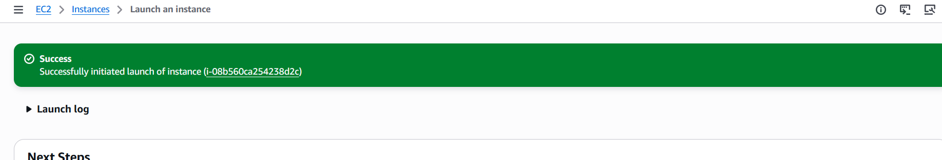
https://prometheus.io/download/
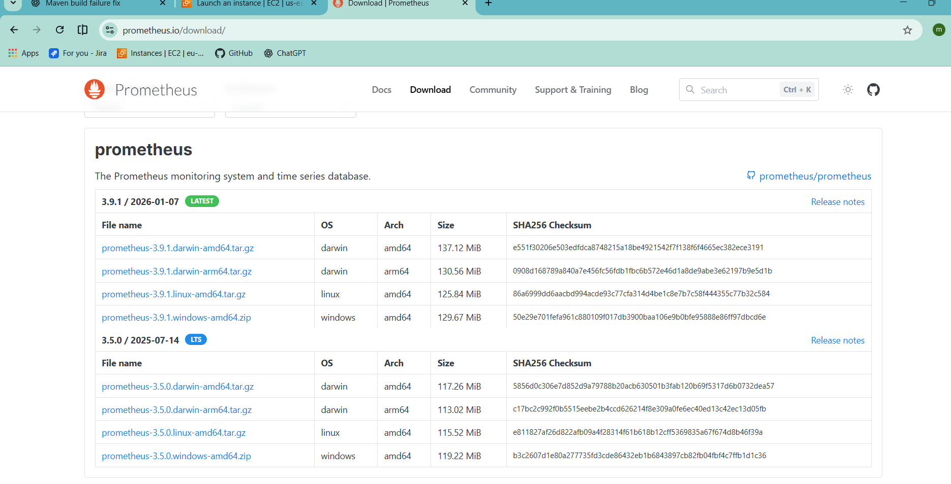
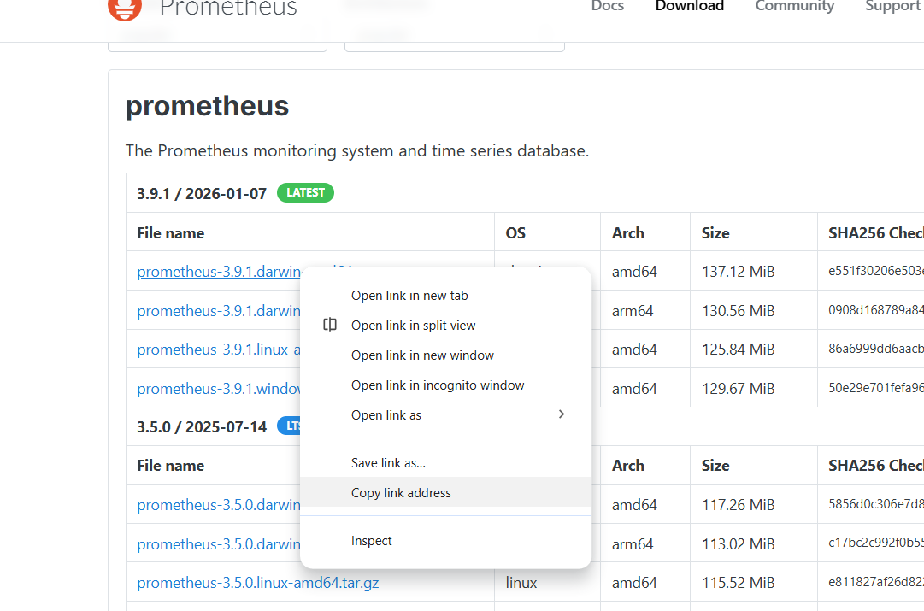

# wget https://github.com/prometheus/prometheus/releases/download/v3.9.1/prometheus-3.9.1.darwin-amd64.tar.gz
# tar -xvf prometheus-3.9.1.darwin-amd64.tar.gz
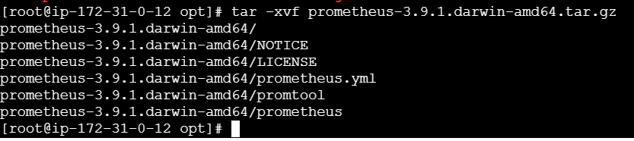
# cd prometheus-3.9.1.linux-amd64/
# ./prometheus --config.file=prometheus.yml
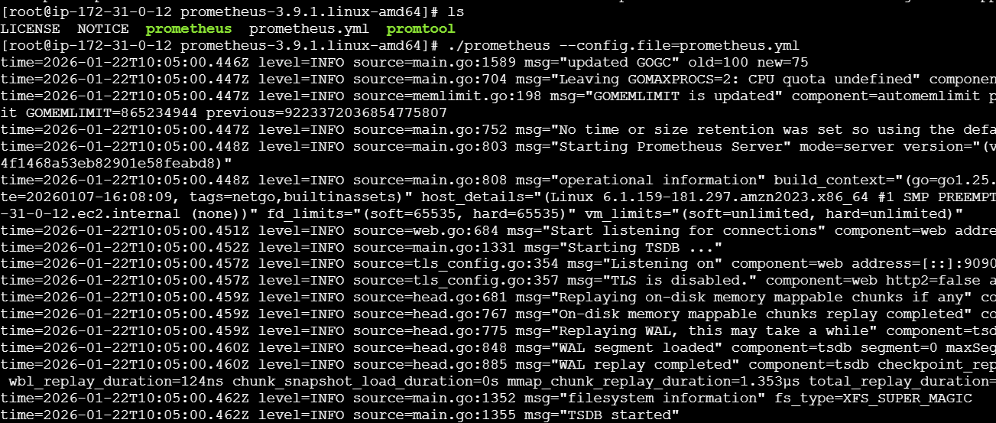
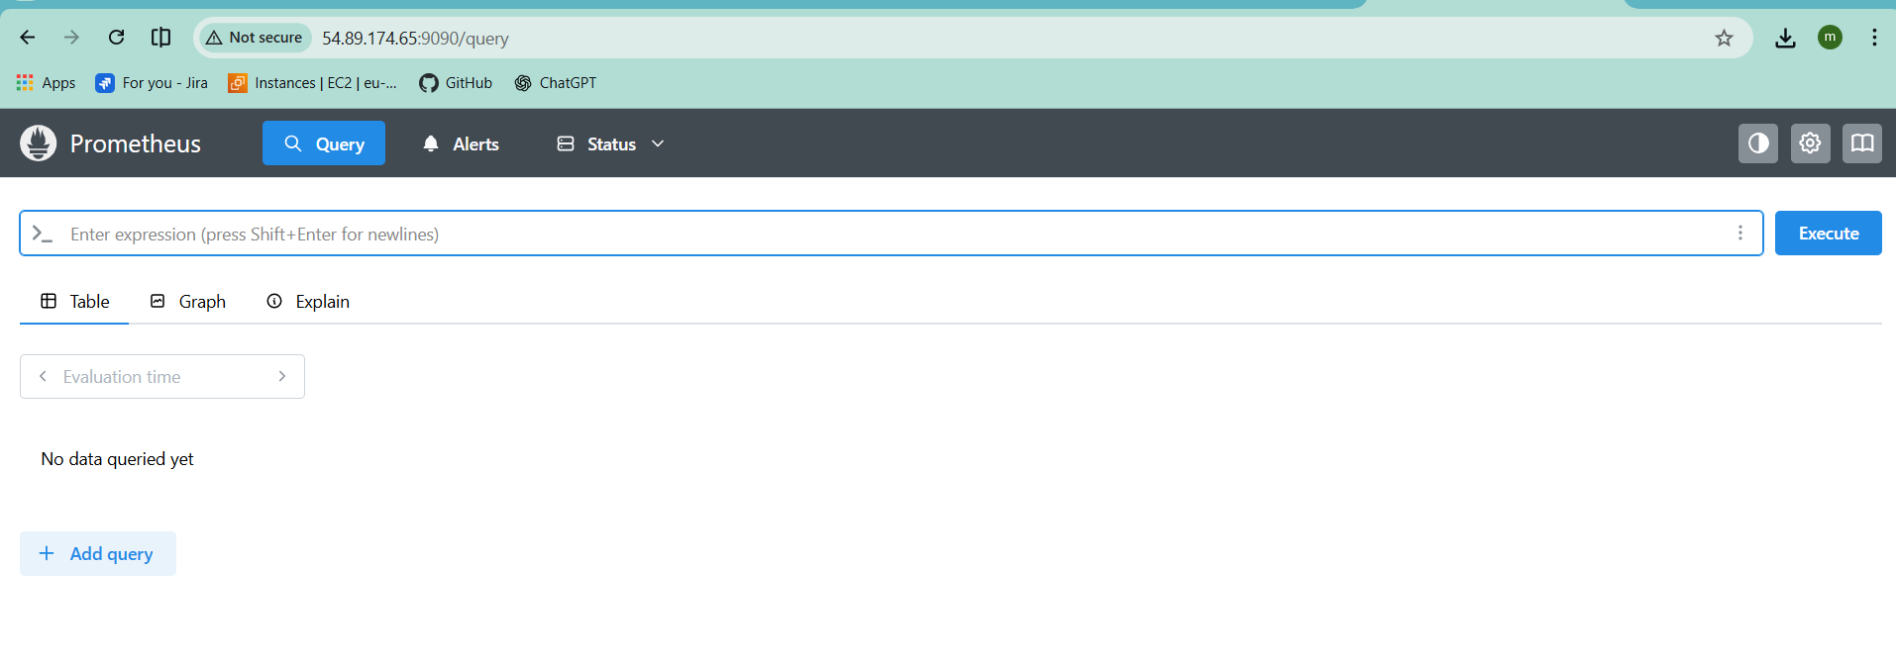
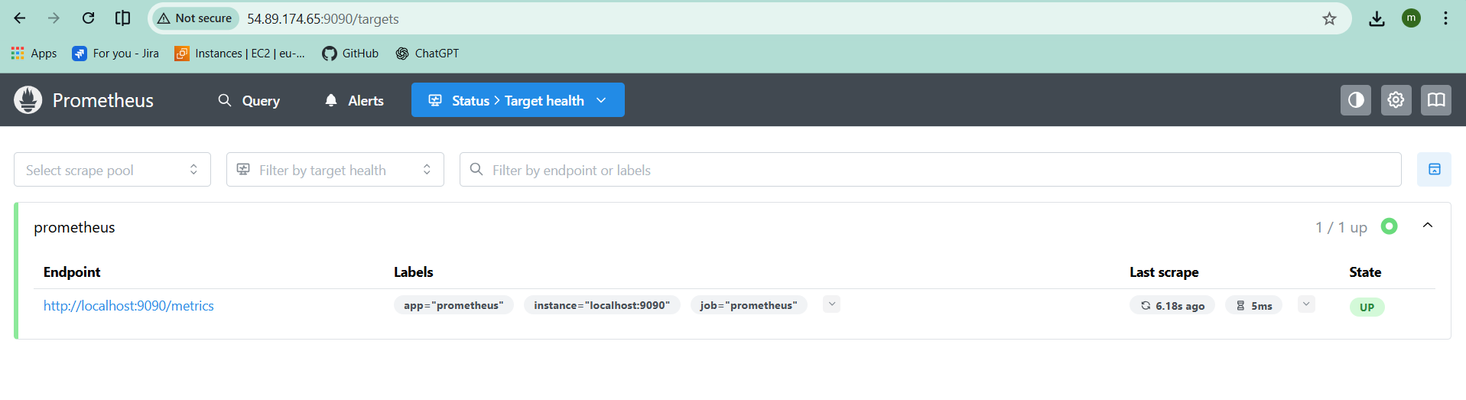

Install and configure Node Exporter for system monitoring.

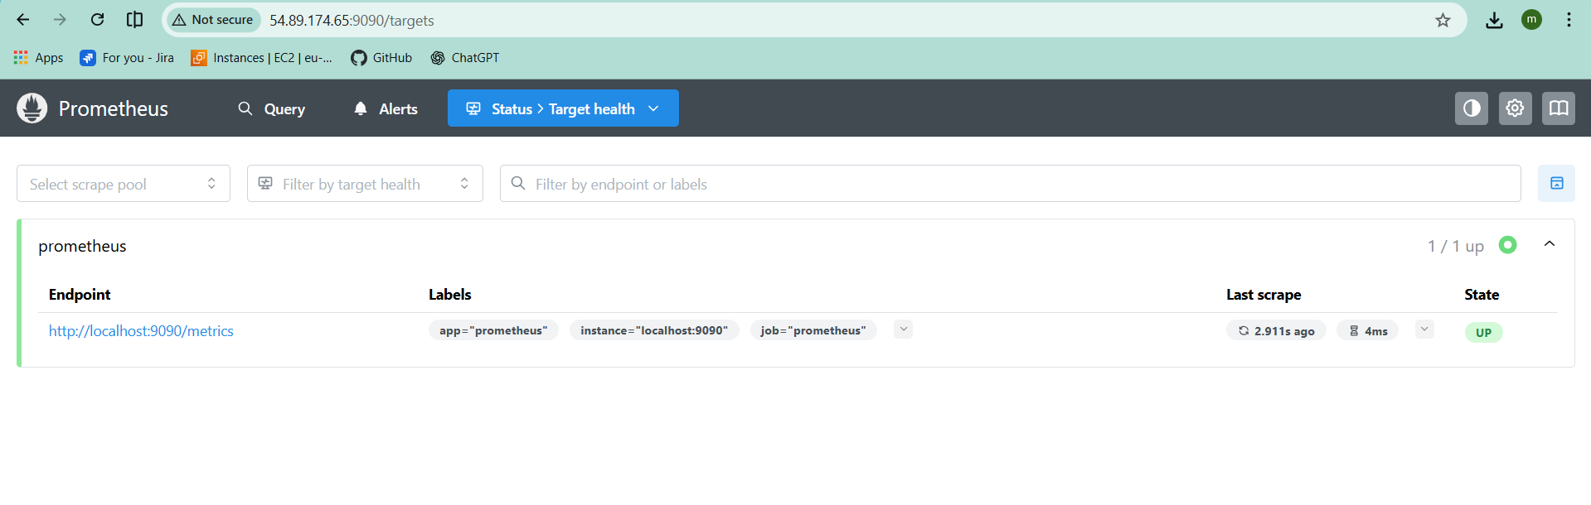
Download node exporter from the link
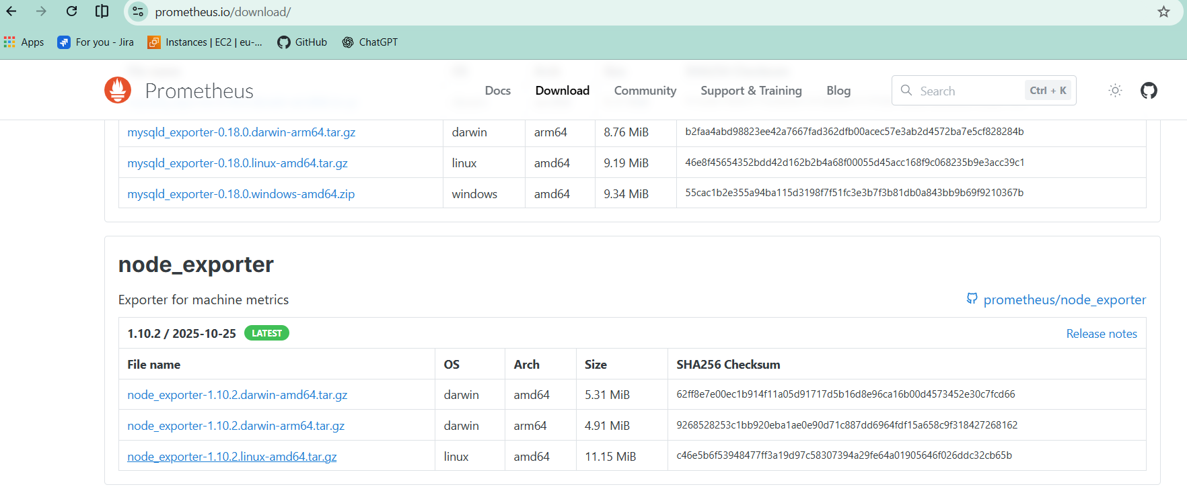
wget https://github.com/prometheus/node_exporter/releases/download/v1.10.2/node_exporter-1.10.2.linux-amd64.tar.gz

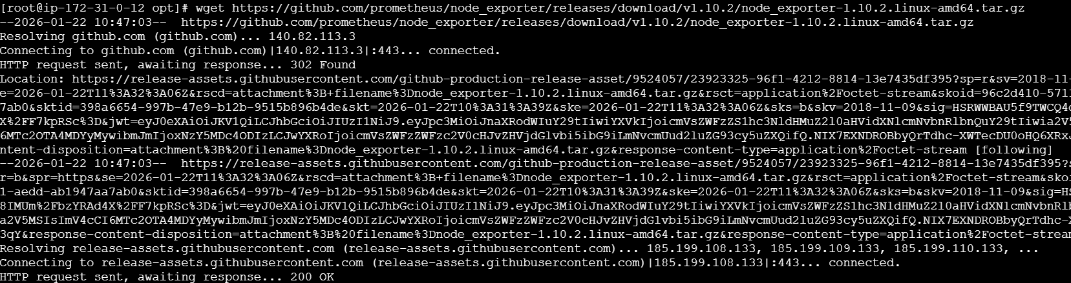
tar -xvf node_exporter-1.10.2.linux-amd64.tar.gz
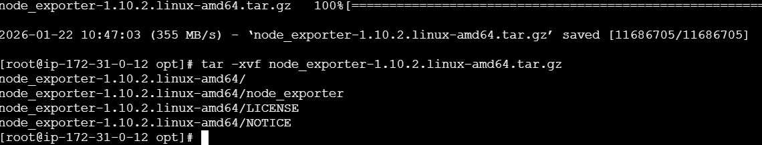
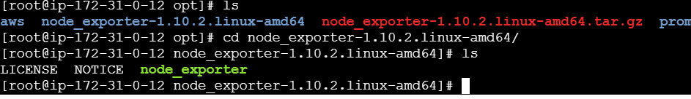
# vi /etc/system/system/node_exporter.service
-
[Unit]
Description=Node Exporter
After=network.target

[Service]
Type=simple
ExecStart=/opt/node_exporter-1.10.2.linux-amd64/node_exporter
Restart=always

[Install]
WantedBy=multi-user.target
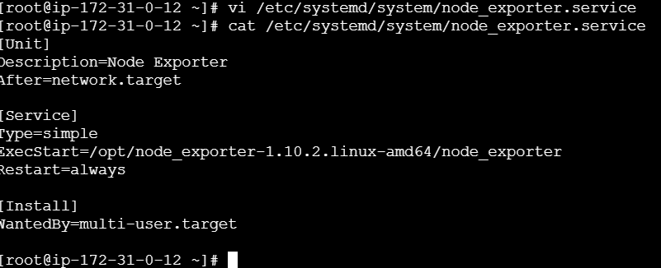
# systemctl daemon-reload
# systemctl restart node_exporter
# systemctl status node_exporter
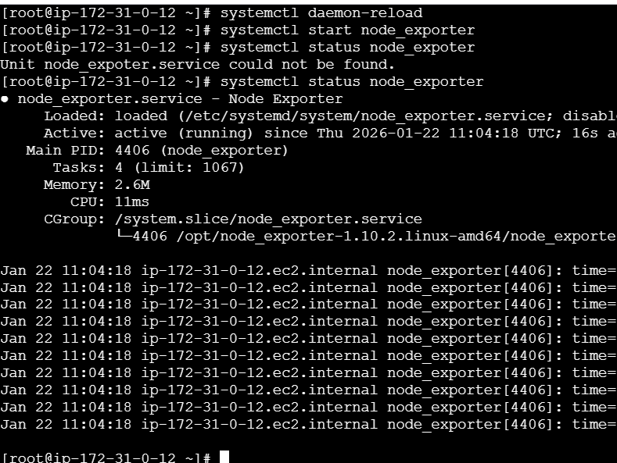
search in browser with the ip 91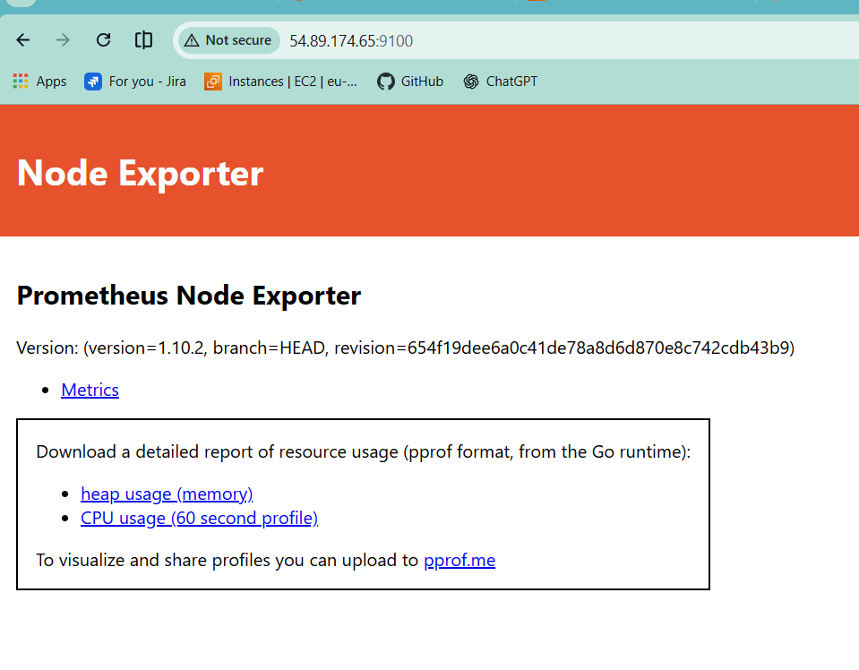
Connect node exporter to Prometheus
# cd /opt/ prometheus-3.9.1.linux-amd64/
# vi Prometheus.yml

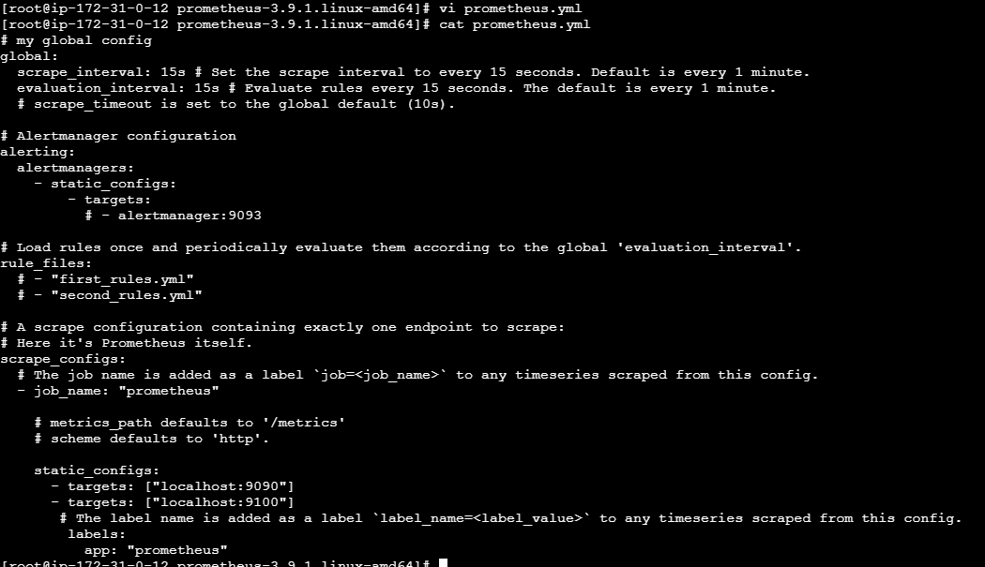
# systemctl restart prometheus
Refresh the page and check
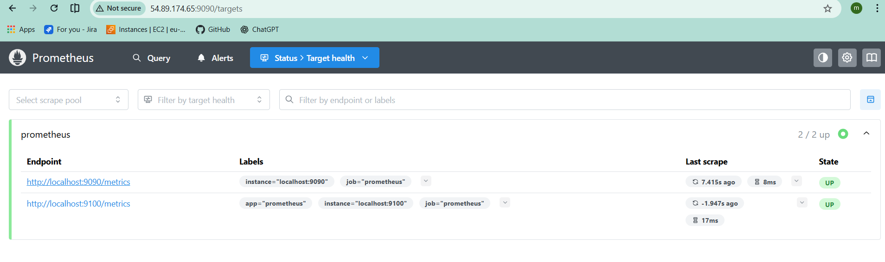
If you want to check the cpu utilization execute this command.
• 100 - (avg by(instance)(irate(node_cpu_seconds_total{mode="idl e"}[1m])) * 100)
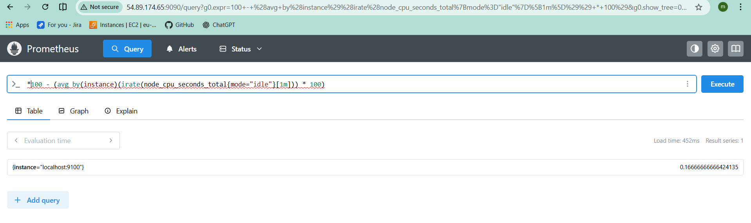

Set up SNMP Exporter to monitor network devices.
Wget https://github.com/prometheus/snmp_exporter/releases/download/v0.25.0/snmp_exporter-0.25.0.linux-amd64.tar.gz
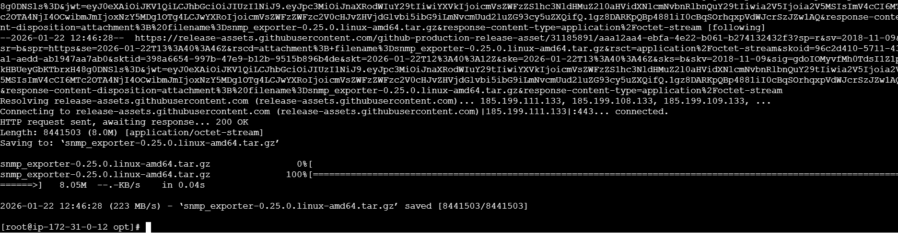
# tar -xvf snmp_exporter-0.25.0.linux-amd64.tar.gz
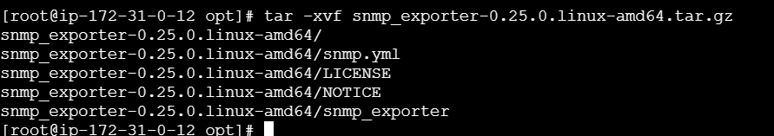
Create a service file for snmp exporter
# vi /etc/systemd/system/snmp_exporter
[Unit]
Description=Prometheus SNMP Exporter
After=network.target

[Service]
Type=simple
ExecStart=/opt/snmp_exporter-0.25.0.linux-amd64/snmp_exporter \
--config.file=/opt/snmp_exporter-0.25.0.linux-amd64/snmp.yml
Restart=always

[Install]
WantedBy=multi-user.target
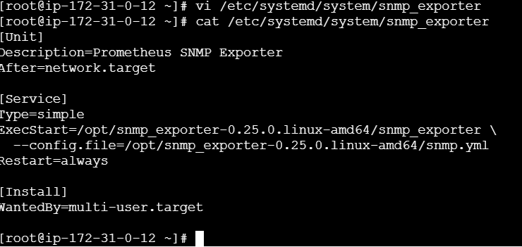
# systemctl daemon-reload
# systemctl start snmp_exporter
# systemctl status snmp_exporter
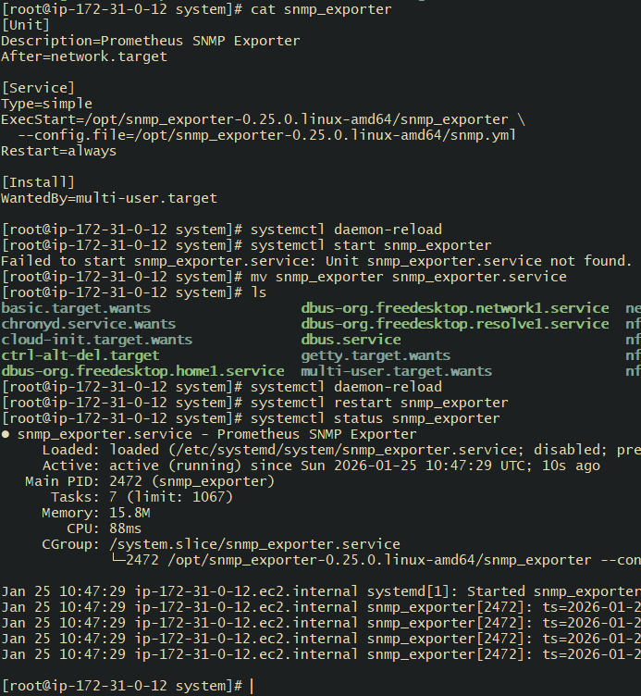
0r
# Cd /opt/ snmp_exporter-0.25.0.linux-amd64
# ./snmp_exporter --config.file=snmp.yml
Check on bowser with the ip_adress:9116
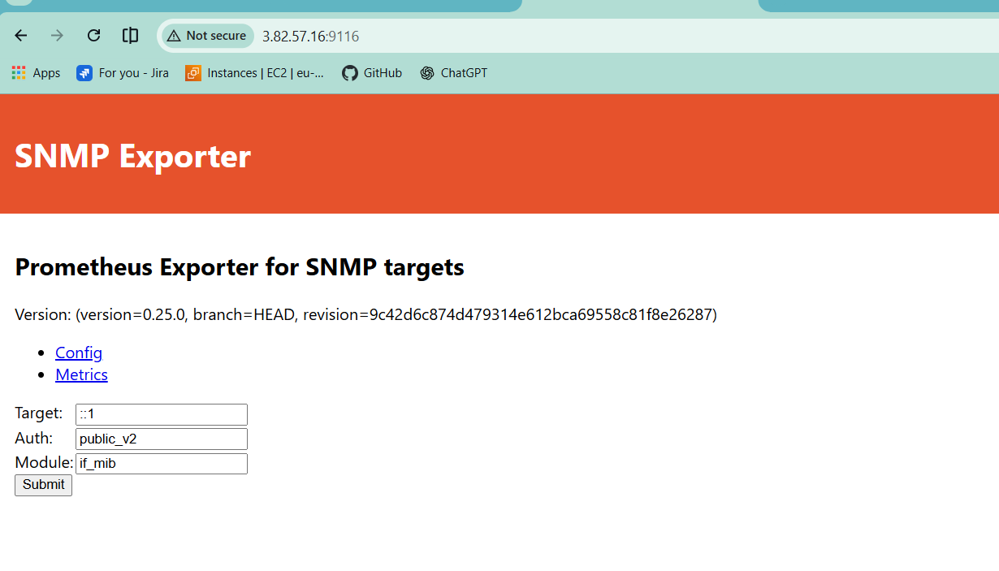
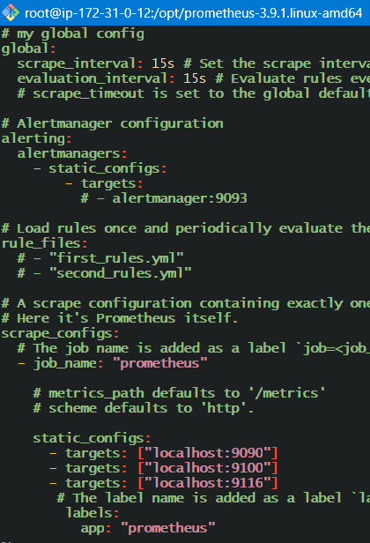

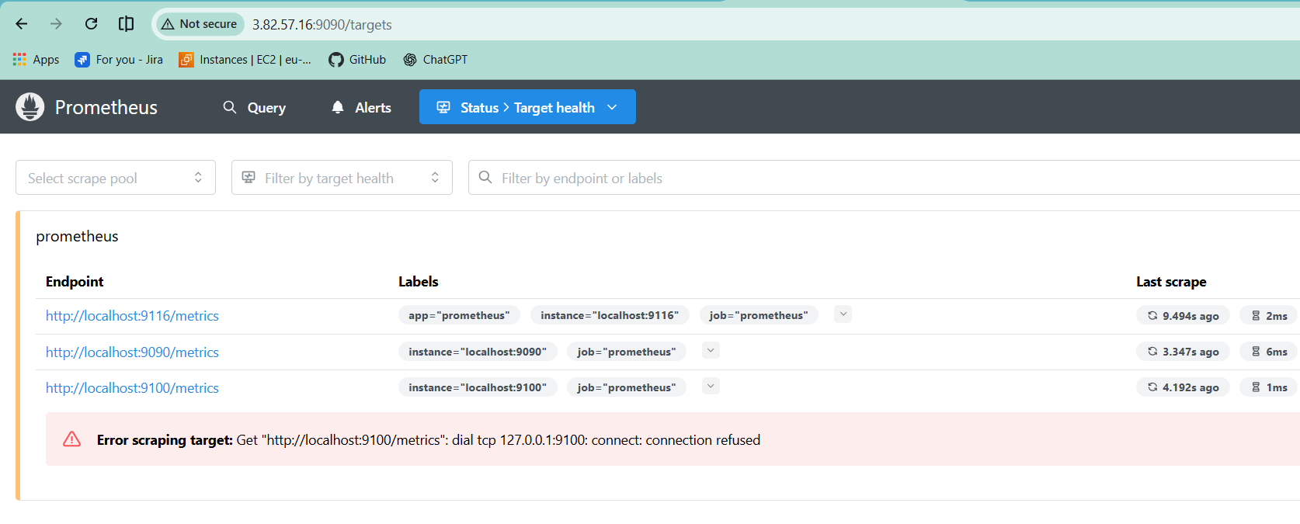

Set up Prometheus to run as a systemd service for automatic startup.
Create a service file Prometheus
# vi /etc/systemd/system/Prometheus.service
# vi /etc/systemd/system/prometheus.service
[Unit]
Description=Prometheus Monitoring Service
After=network.target

[Service]
Type=simple
ExecStart=/opt/prometheus-3.9.1.linux-amd64/prometheus \
--config.file=/opt/prometheus-3.9.1.linux-amd64/prometheus.yml \
--storage.tsdb.path=/opt/prometheus-3.9.1.linux-amd64/data
Restart=always

[Install]
WantedBy=multi-user.target
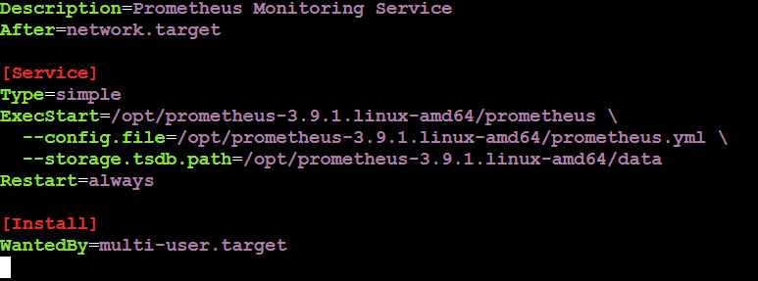
systemctl daemon-reload
systemctl restart Prometheus
systemctl status Prometheus
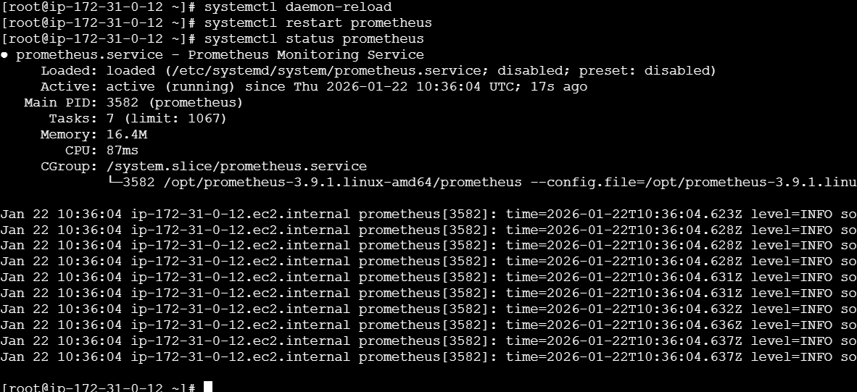

Install Alertmanager and configure an email alert.
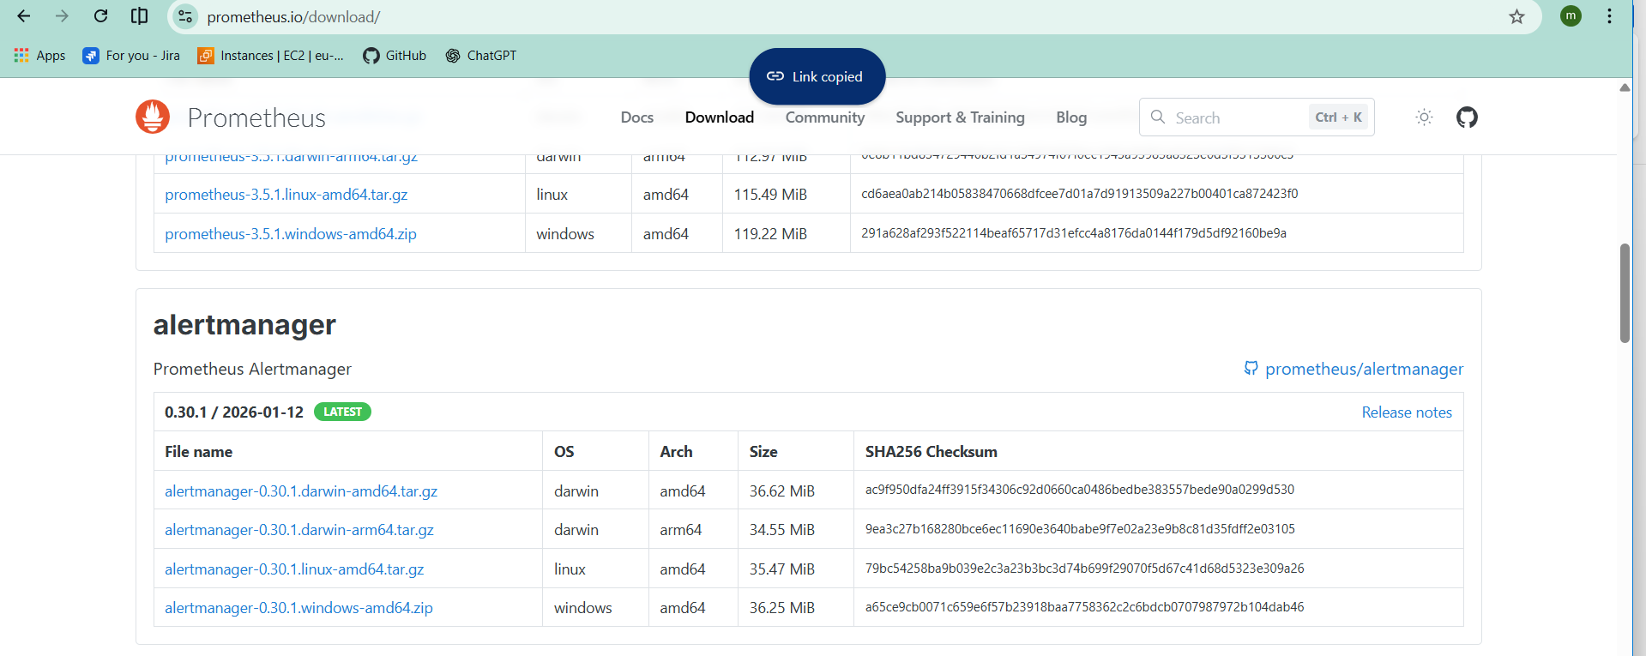
# wget https://github.com/prometheus/alertmanager/releases/download/v0.30.1/alertmanager-0.30.1.linux-amd64.tar.gz
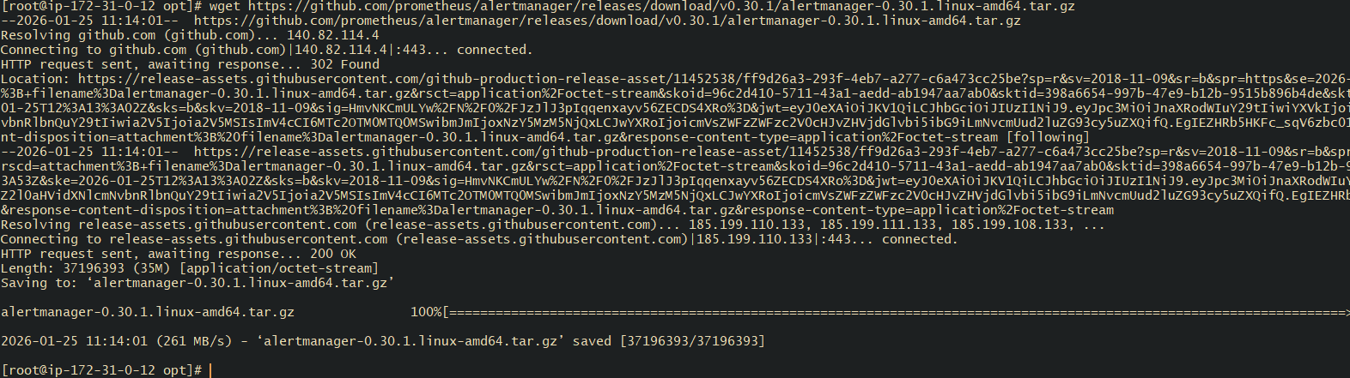
# tar -xvf alertmanager-0.30.1.linux-amd64.tar.gz
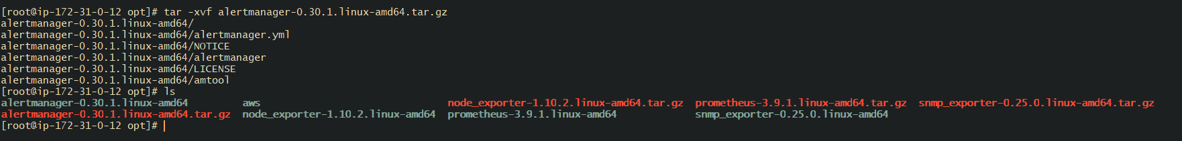
# cd alertmanager-0.30.1.linux-amd64/
#vi alertamanager.yml
global:
smtp_smarthost: 'smtp.gmail.com:587'
smtp_from: 'pmohd6065@gmail.com'
smtp_auth_username: 'pmohd6065.com'
smtp_auth_password: '7416745928'
smtp_require_tls: true

route:
receiver: 'email-alerts'

receivers:
- name: 'email-alerts'
email_configs:
- to: 'pmohd6065@gmail.com'
send_resolved: true
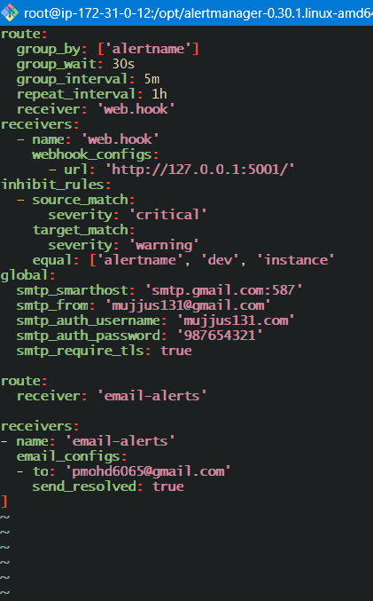
Create a service file for alertmanager
# vi /etc/systemd/system/alertmanager.service
[Unit]
Description=Alertmanager Service
After=network.target

[Service]
Type=simple
ExecStart=/opt/alertmanager-0.30.1.linux-amd64/alertmanager \
--config.file=/opt/alertmanager-0.30.1.linux-amd64/alertmanager.yml \
--storage.path=/opt/alertmanager-0.30.1.linux-amd64/data
Restart=always

[Install]
WantedBy=multi-user.target
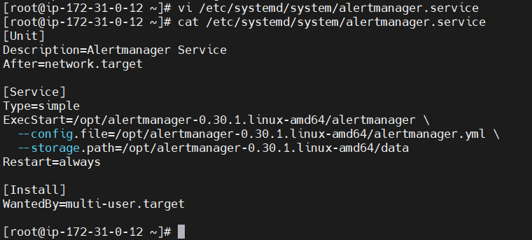
#systemctl daemon-reload
#systemctl restart alertmanager
#systemctl status alertmanager
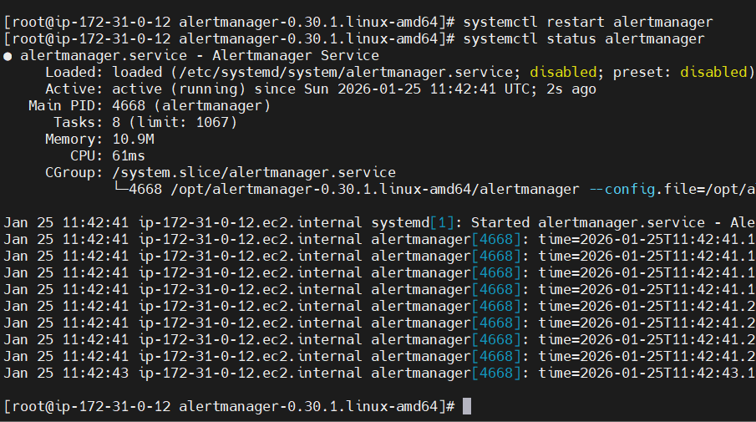
Check on the browser with ip address and port number(9093)
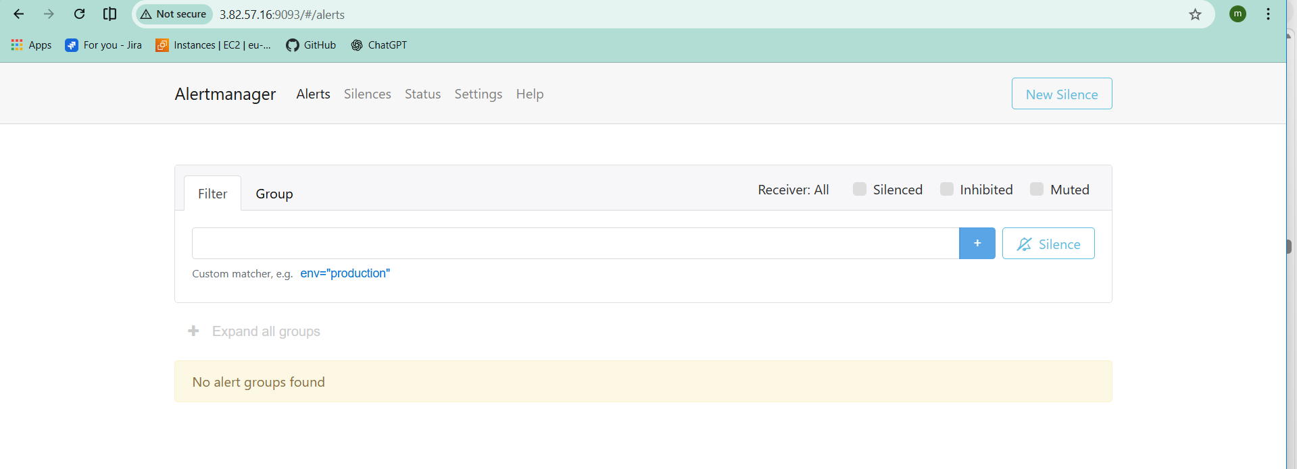

Connect alertmanager to prometheus
Go to Prometheus directory
# vi Prometheus.yml
add the port of alertmanager
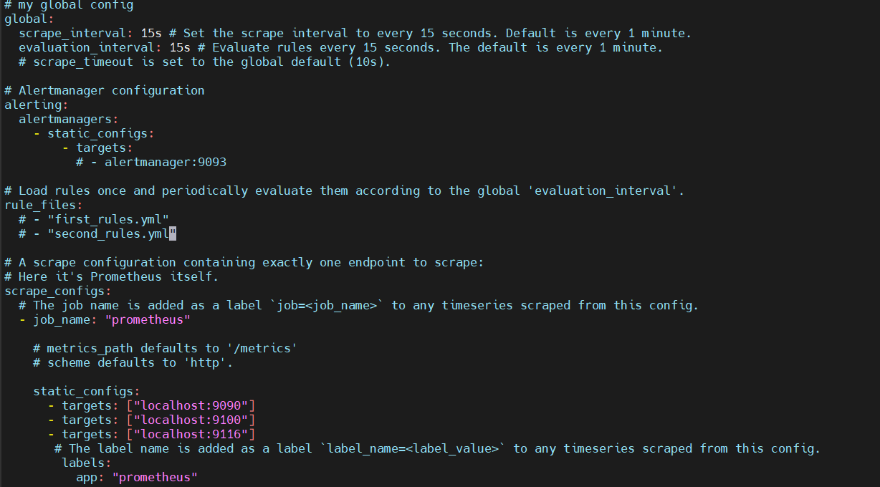
Make the cahnges
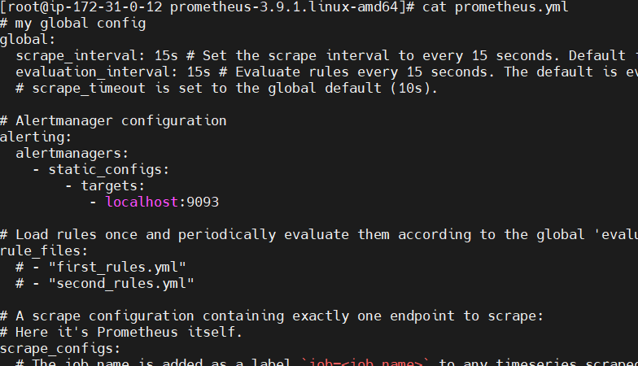
# systemctl restart prometheus

#mkdir rules
# cd rules
#vi alerts.yml
- - >
groups:
- name: system-alerts
rules:
- alert: HighCPUUsage
expr: 100 - (avg by(instance)(irate(node_cpu_seconds_total{mode="idle"}[2m])) * 100) > 80
for: 1m
labels:
severity: critical
annotations:
summary: "High CPU Usage"
description: "CPU usage is above 80% for more than 1 minute"

- alert: HighMemoryUsage
expr: (1 - (node_memory_MemAvailable_bytes / node_memory_MemTotal_bytes)) * 100 > 85
for: 1m
labels:
severity: warning
annotations:
summary: "High Memory Usage"
description: "Memory usage is above 85%"
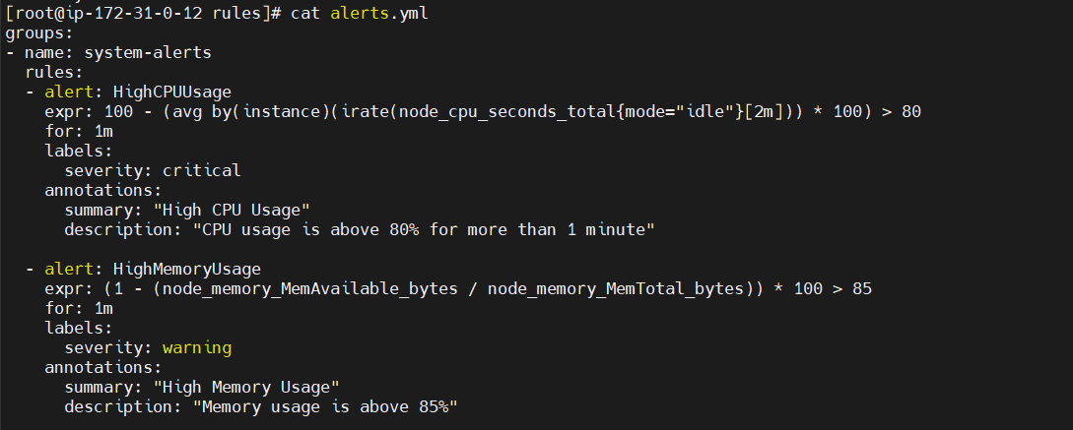
Now Go to Prometheus.yml file add your alert file in the Prometheus file.
Add this to rules
- “rules/*.yml”
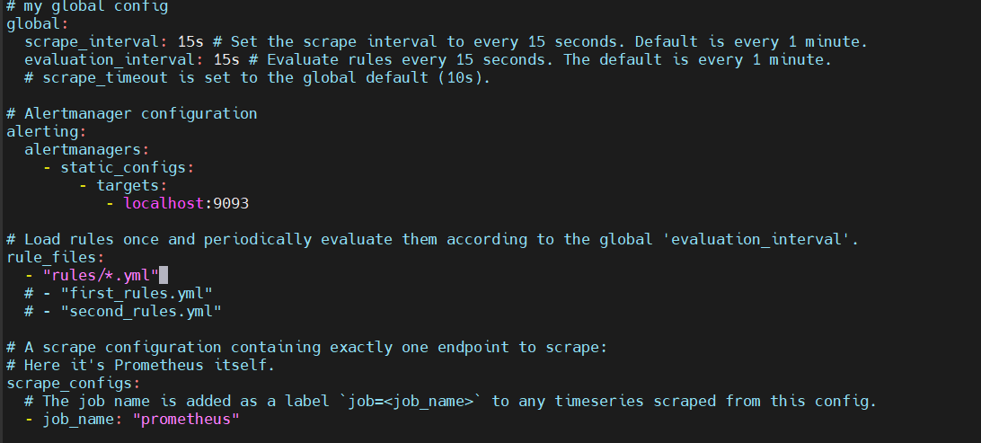
You can test that alert by sending fake load to that server. Search in browser with ip and port 9000:alerts
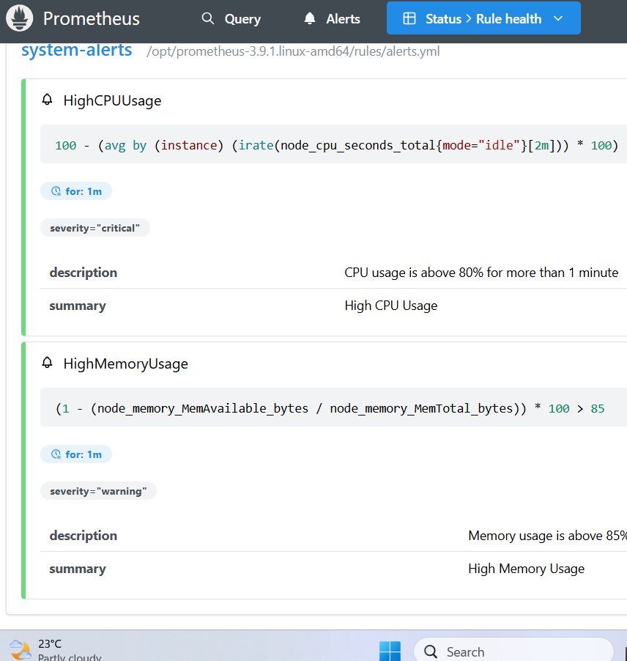

Install Grafana and add Prometheus as a data source.
Download Grafana by this commands in Prometheus server
• wget https://dl.grafana.com/grafana-enterprise/release/12.3.1/grafana-enterprise_12.3.1_20271043721_linux_amd64.tar.gz
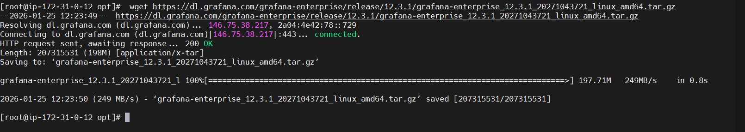
• tar -zxvf grafanaenterprise_12.3.1_20271043721_linux_amd64.tar.gz
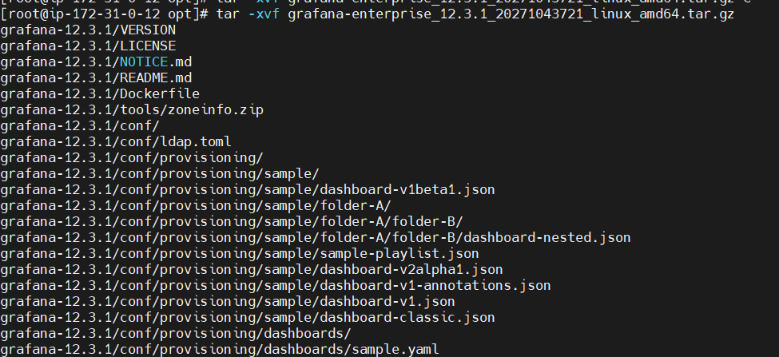
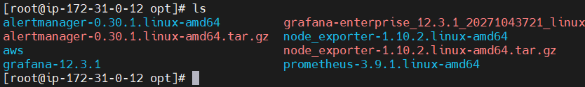
Acess on the browser using ip and port:3000

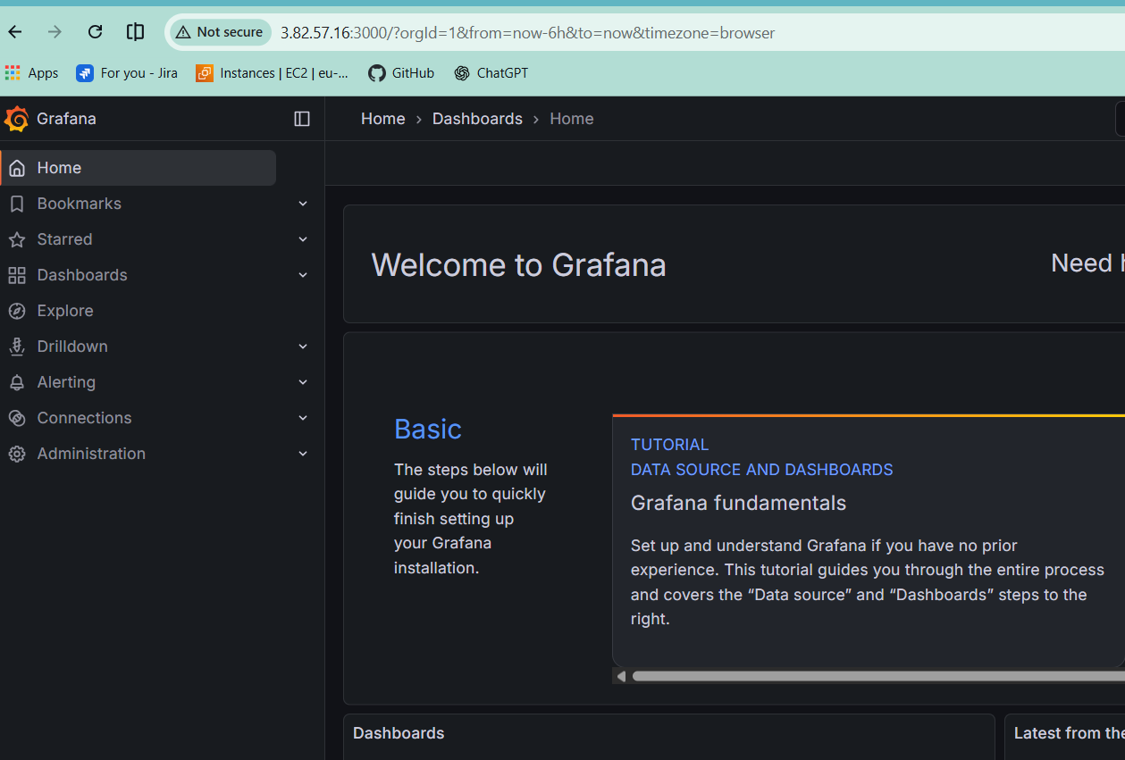
Go to connections and search for Prometheus

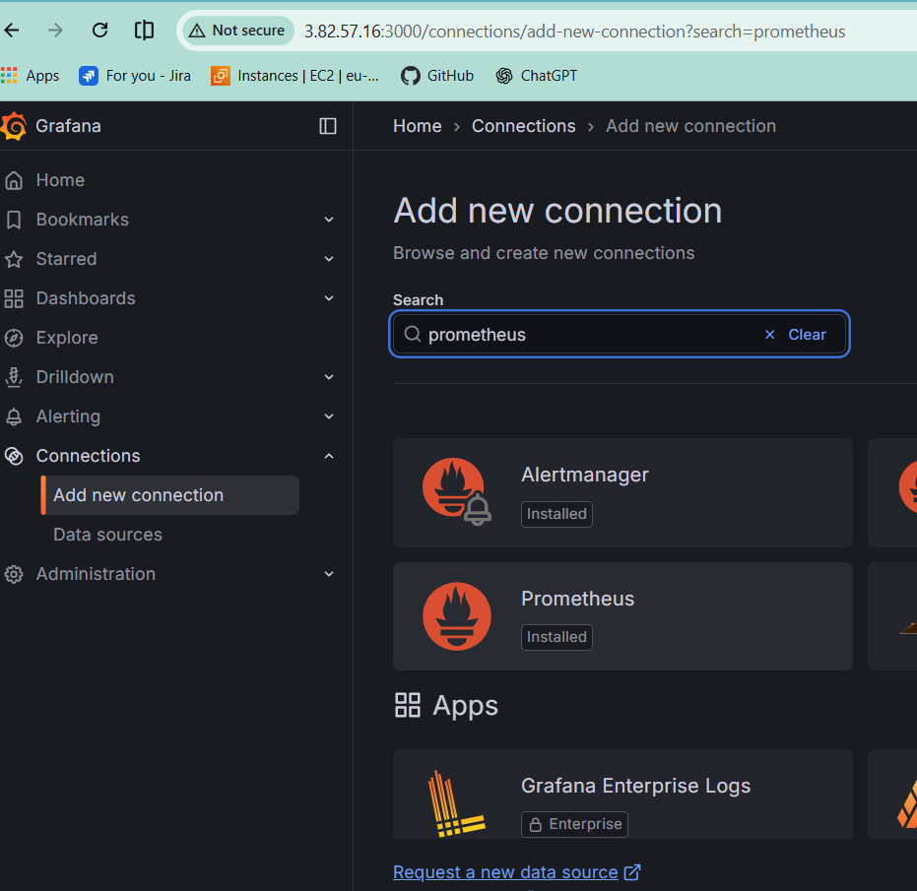

Add new data source
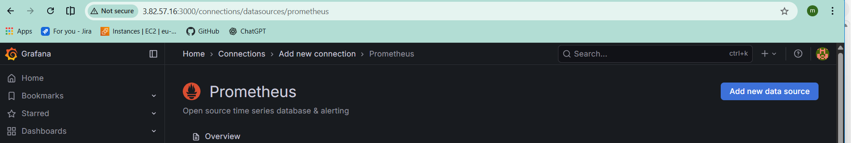
Pass the ip address and port
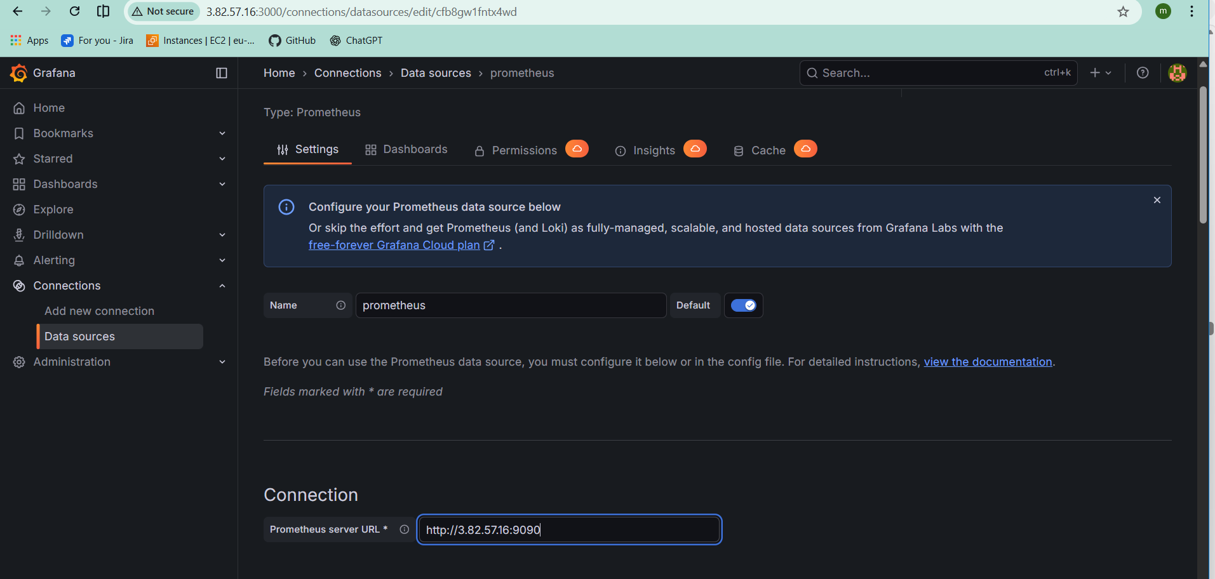
Scroll down and click on save and test
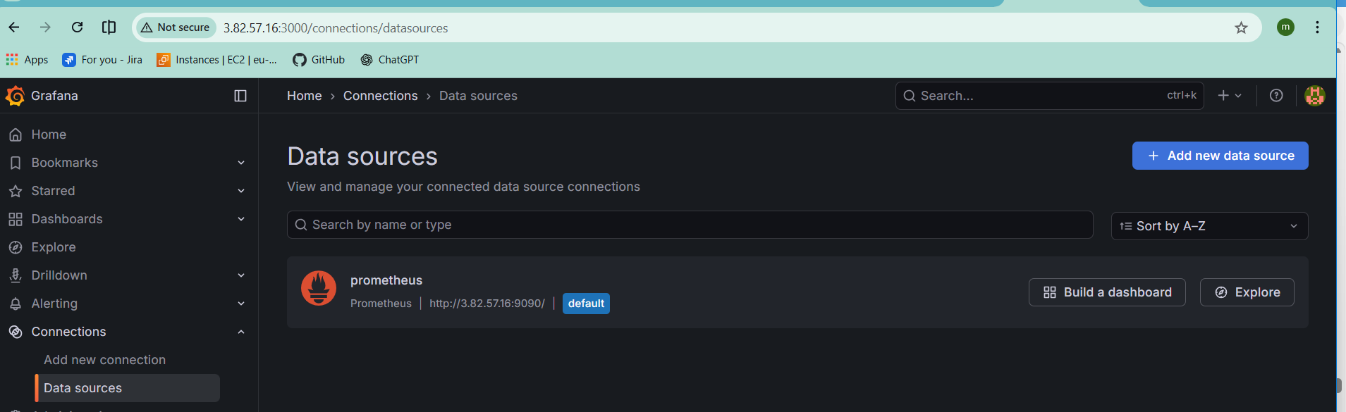
Create new dash board
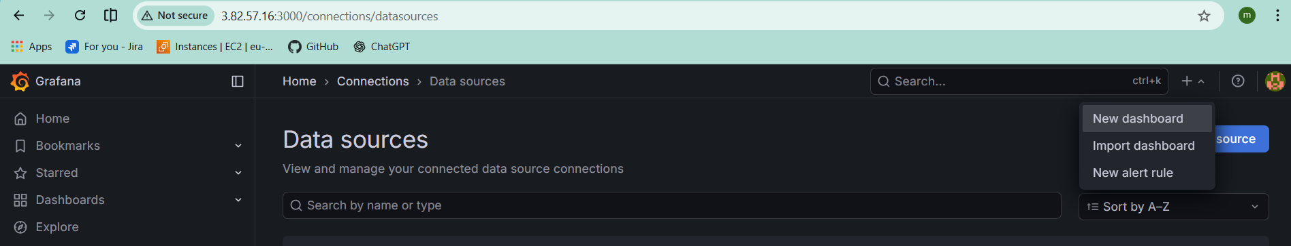
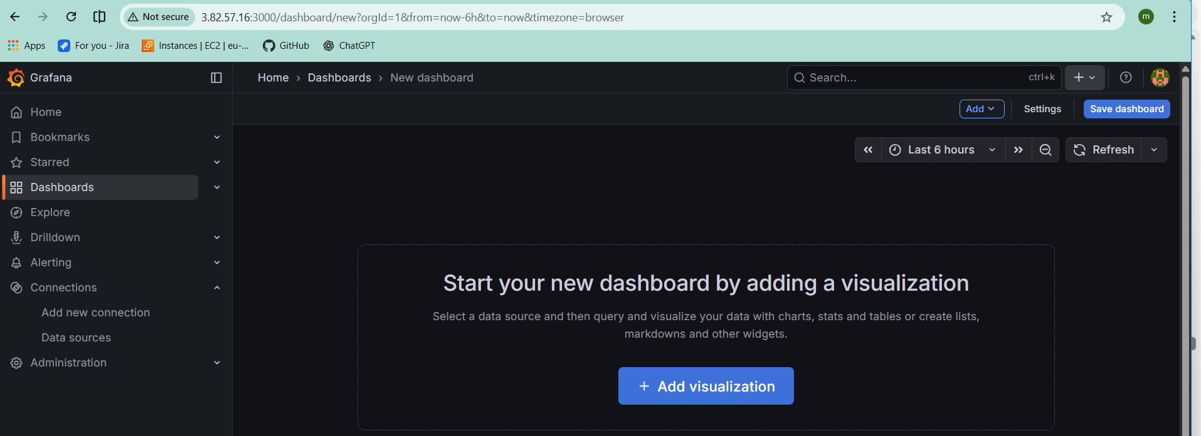
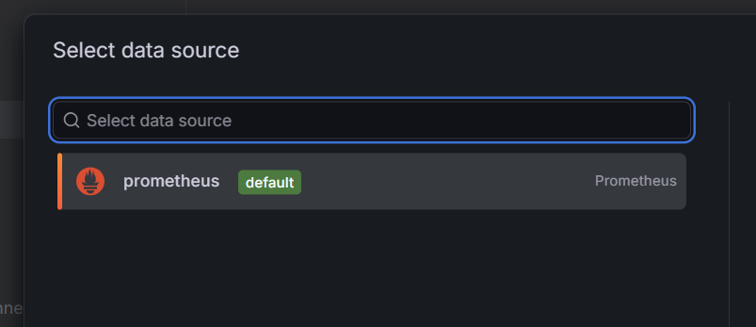
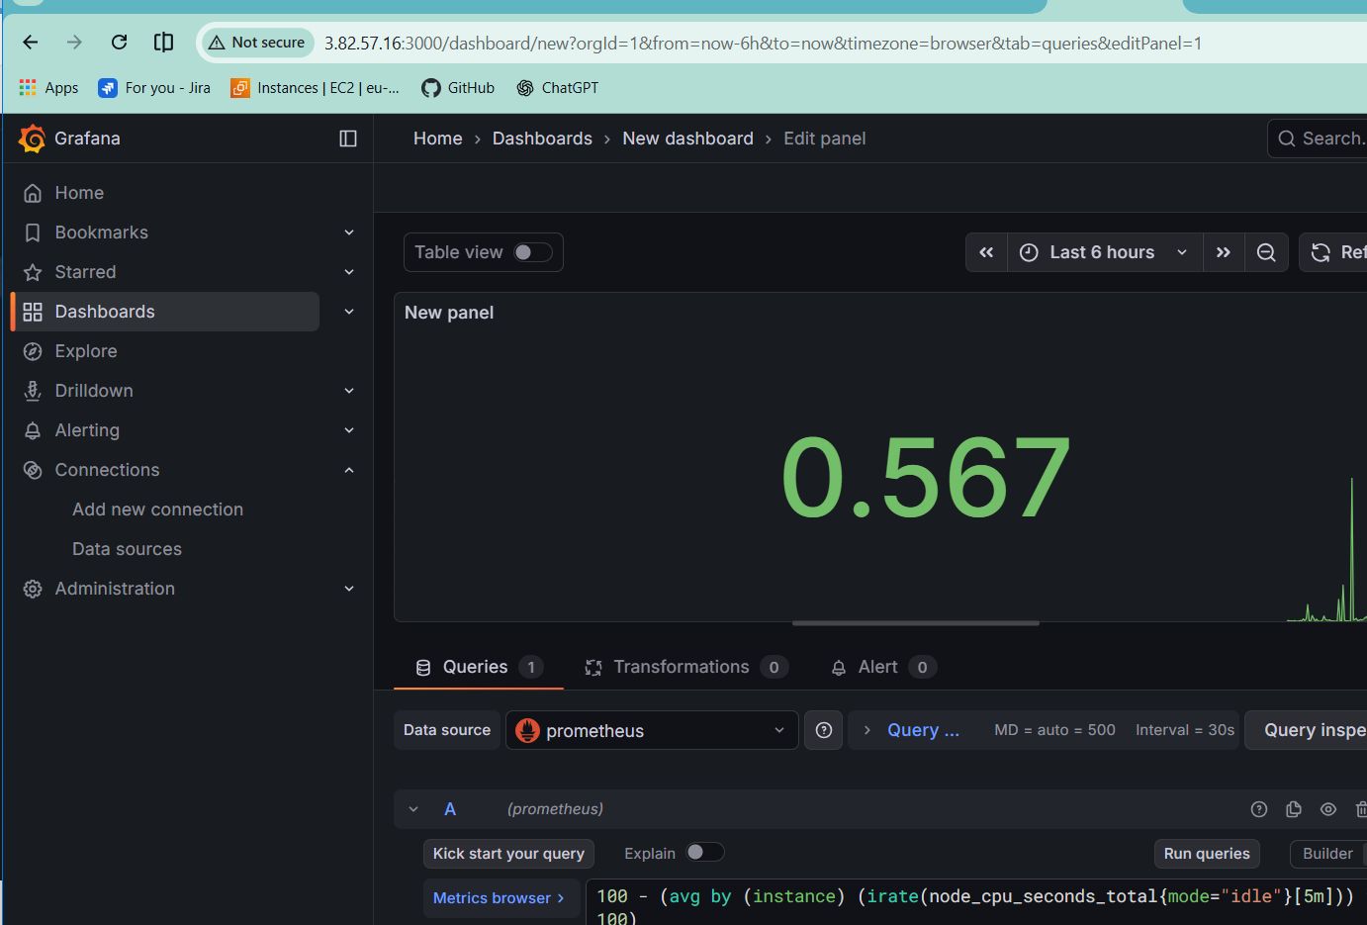

Configure Prometheus for service discovery of dynamic targets.
Create ec2-instance with the name service discovery
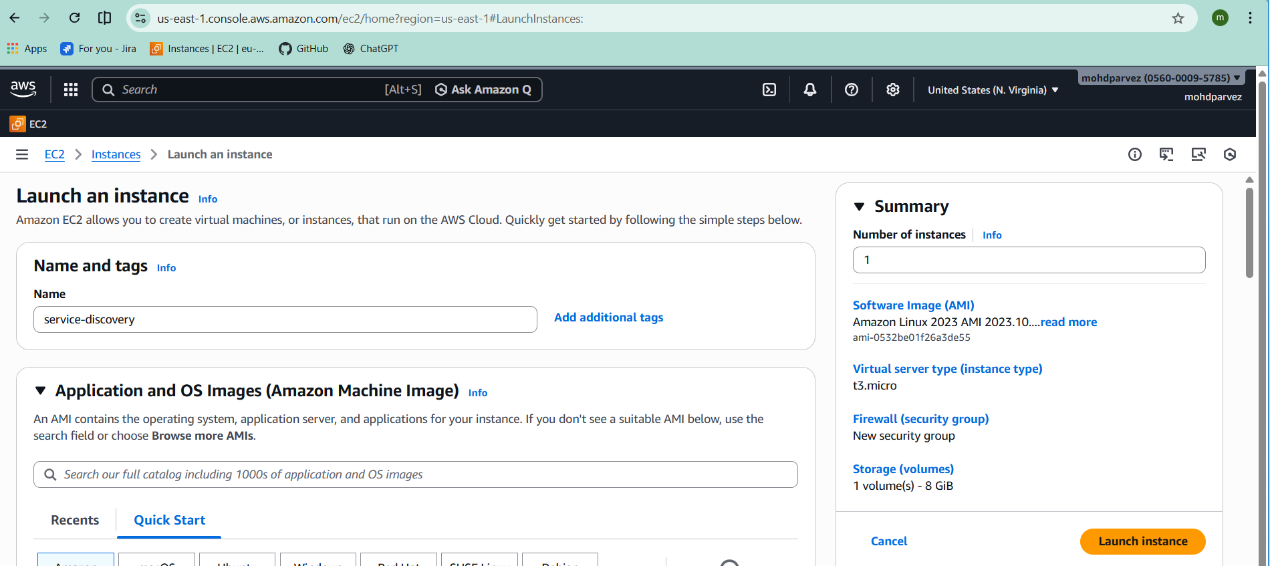
Copy the link of node exporter and wget in the target machine
# Wget https://github.com/prometheus/node_exporter/releases/download/v1.10.2/node_exporter-1.10.2.linux-amd64.tar.gz

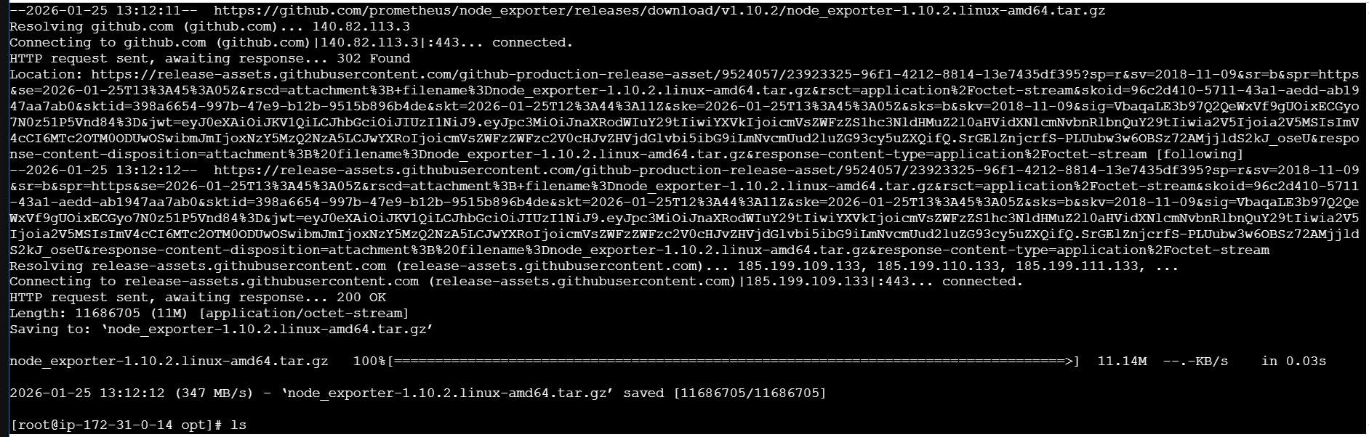
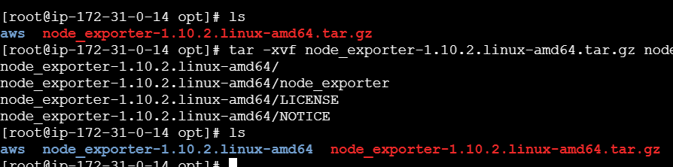
# tar -xvf node_exporter-1.10.2.linux-amd64.tar.gz
# vi /etc/systemd/system/node_exporter.service
[Unit]
Description=Node Exporter
After=network.target
[Service]
User=nobody
ExecStart=/opt/node_exporter-1.10.2.linux-amd64/node_exporter
Restart=on-failure
[Install]
WantedBy=multi-user.target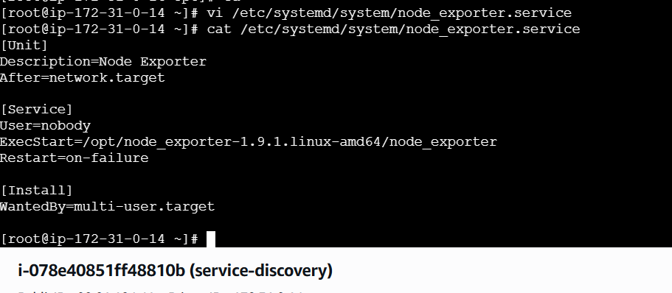
# systemctl daemon-reload
# systemctl restart node_exporter
# systemctl status node_exporter
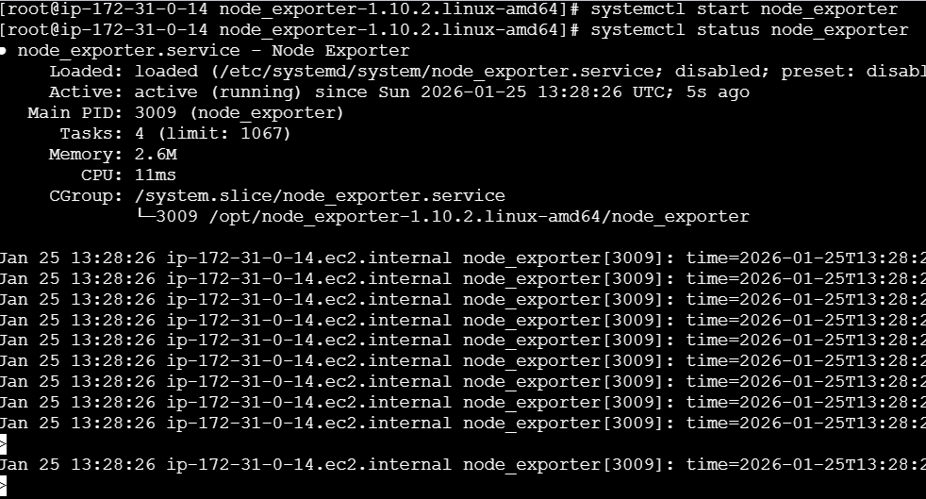
Connect discovery file to Prometheus server. Go to Prometheus service and add the target ip address of your discovery service file.
In Prometheus server
# cd /opt/prometheus-3.9.1.linux-amd64/
# vi prometheus.yml

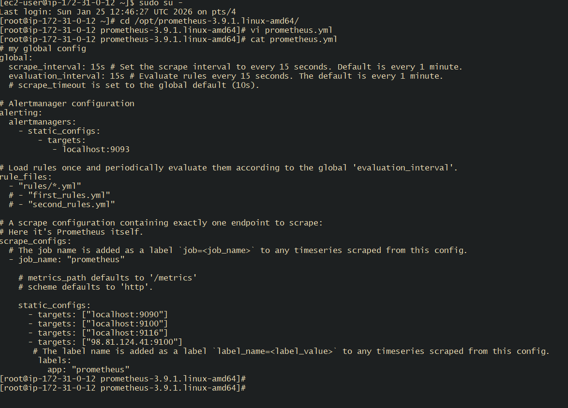
# systemctl restart prometheus

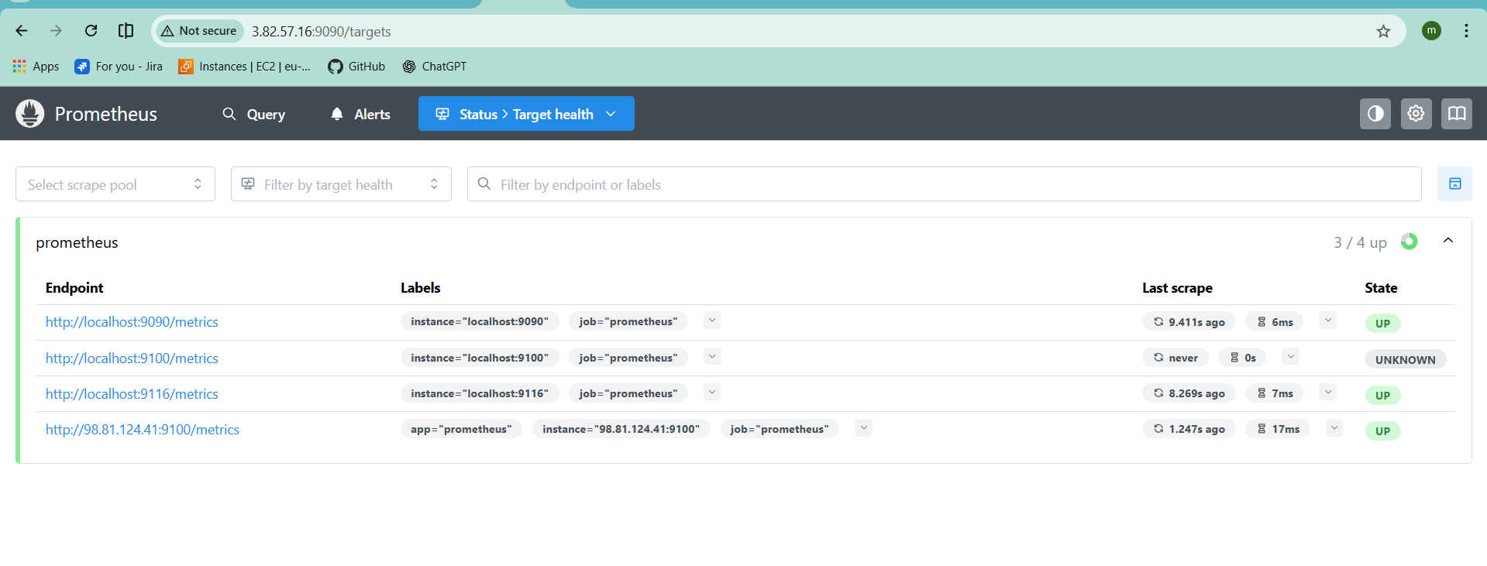
Go to IAM and create a policy with this code name as testprometheus
{
"Version": "2012-10-17",
"Statement": [
{
"Effect": "Allow",
"Action": [
"ec2:DescribeInstances",
"ec2:DescribeTags"
],
"Resource": "*"
}
]
}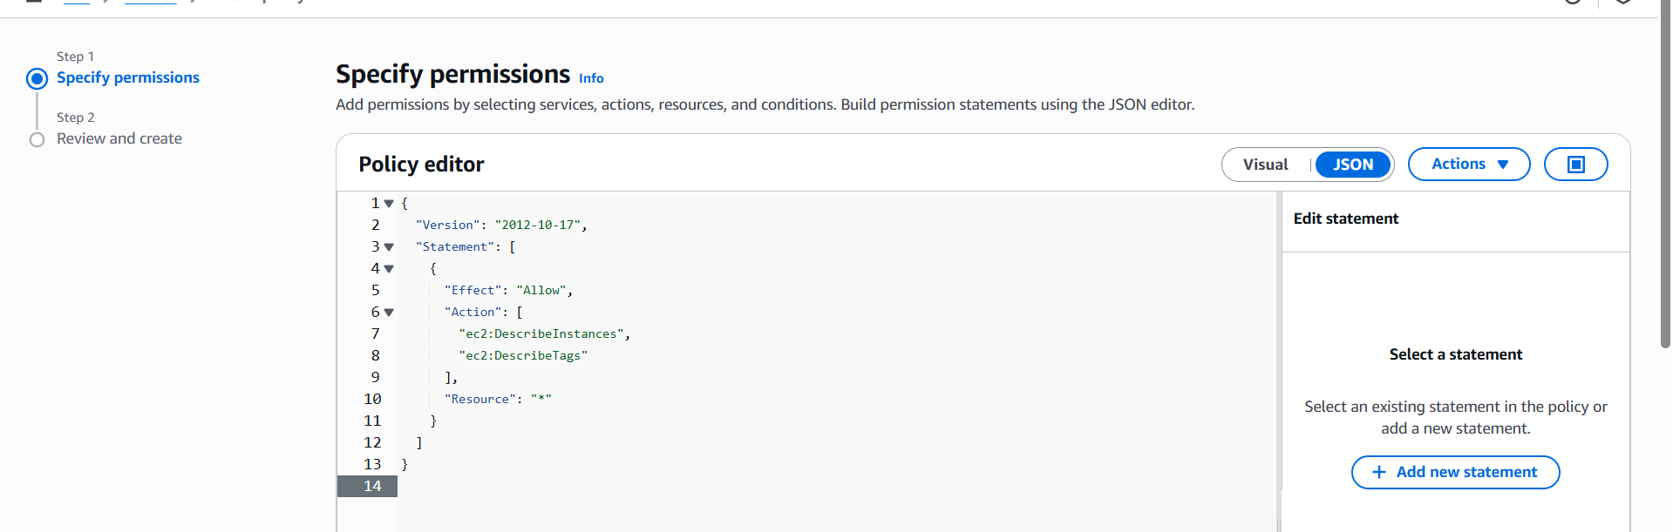
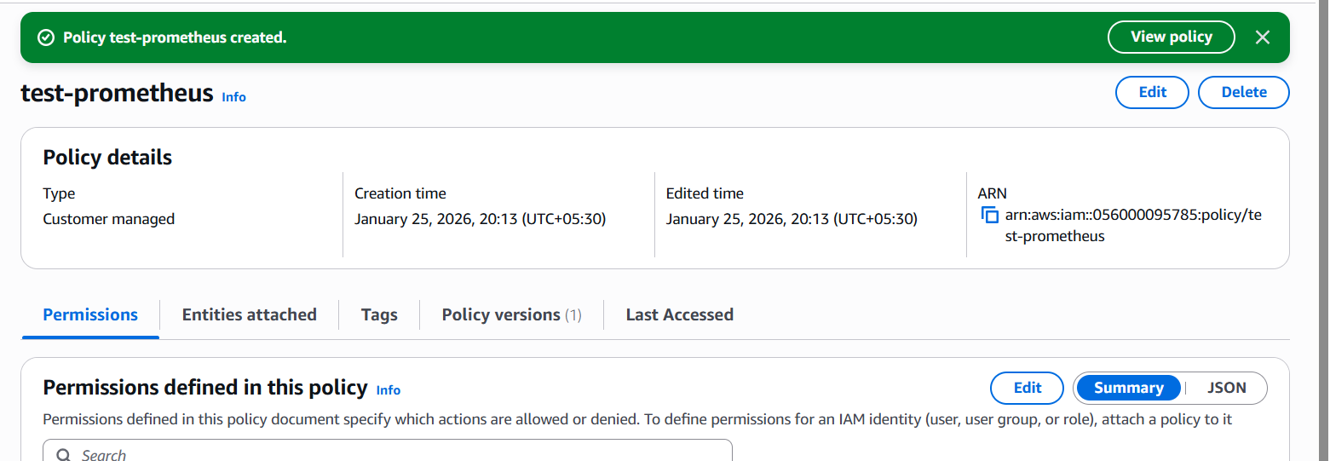
Create role and attch the policy
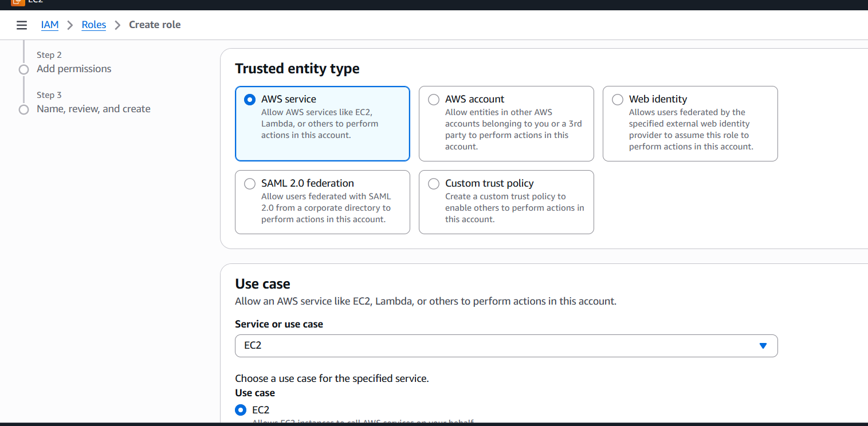
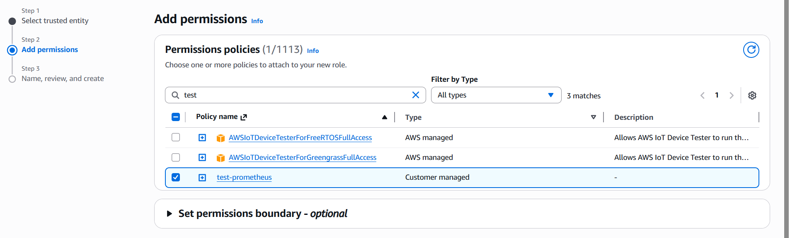
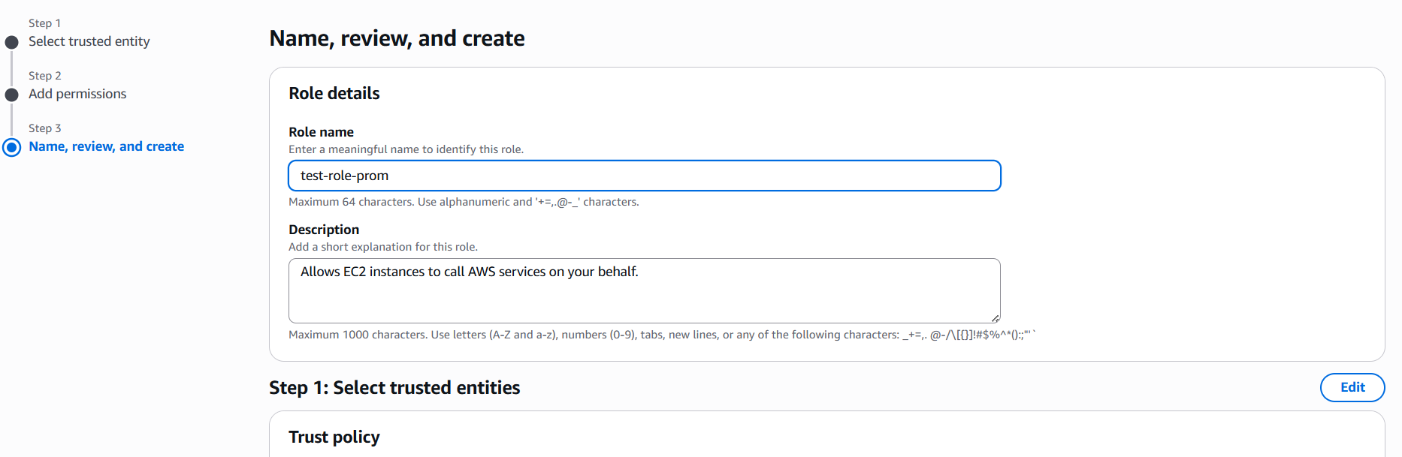
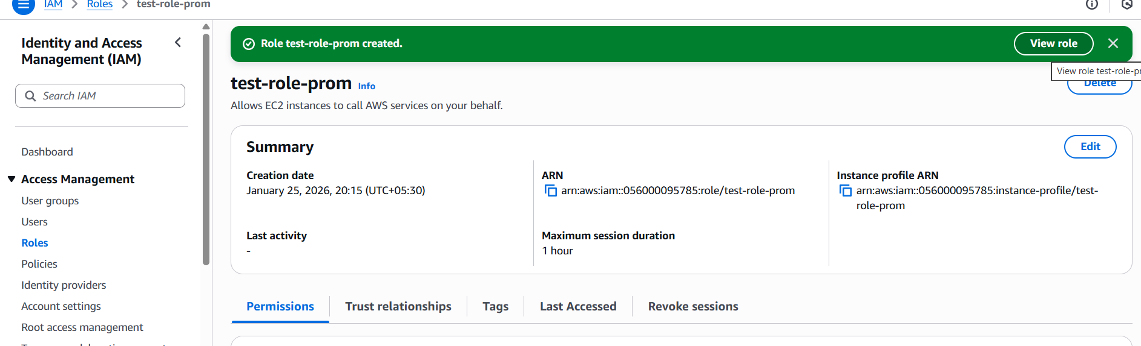
Attach the role to the Prometheus server
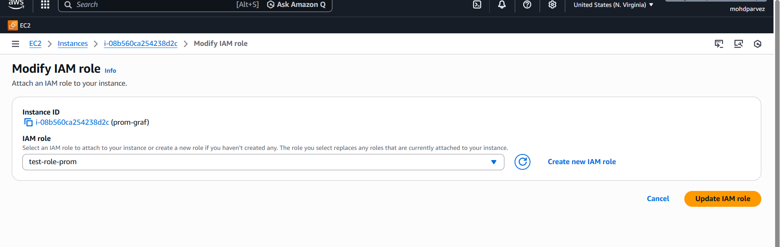
If you create a new instance with the name Prometheus-node (It was a label that you provided in the script)then it will automatically monitor into your target health in Prometheus server
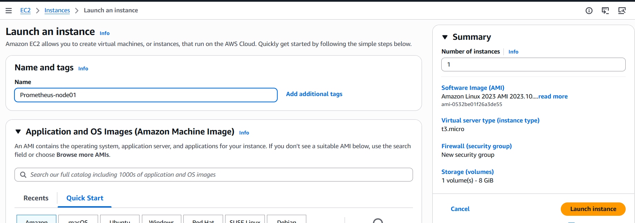
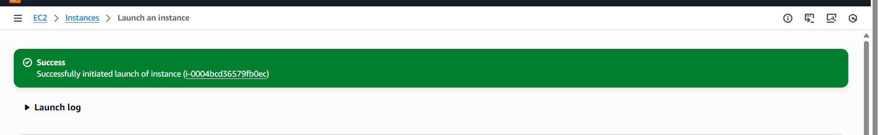
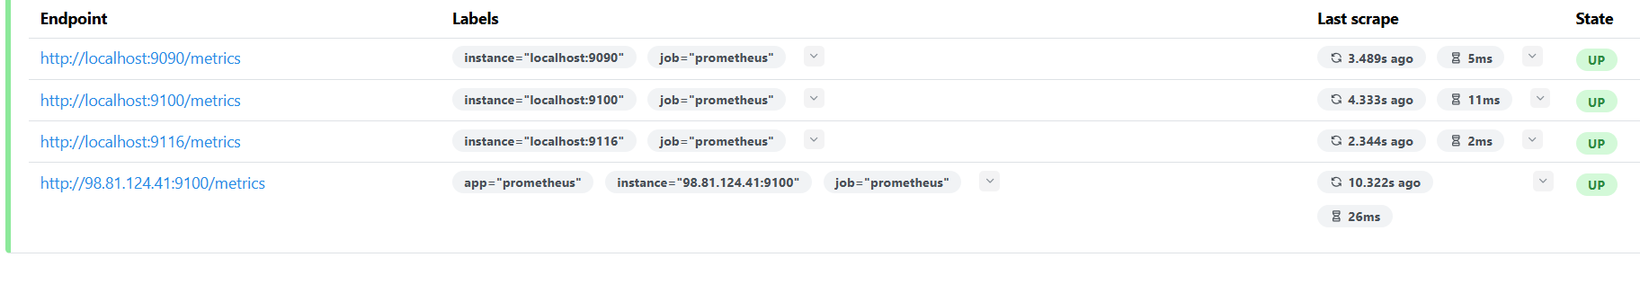

Create alerting rules for monitoring disk space.
Go to Prometheus server and create a file disk_alerts.yml
groups:
- name: disk_alerts
rules:
- alert: DiskSpaceLow
expr: |
(node_filesystem_avail_bytes{fstype!~"tmpfs|overlay"} /
node_filesystem_size_bytes{fstype!~"tmpfs|overlay"}) * 100 < 15
for: 2m
labels:
severity: warning
annotations:
summary: "Low disk space on {{ $labels.instance }}"
description: "Disk available is below 15% on {{ $labels.mountpoint }} (instance {{ $labels.instance }})"

- alert: DiskSpaceCritical
expr: |
(node_filesystem_avail_bytes{fstype!~"tmpfs|overlay"} /
node_filesystem_size_bytes{fstype!~"tmpfs|overlay"}) * 100 < 5
for: 1m
labels:
severity: critical
annotations:
summary: "CRITICAL: Disk space very low on {{ $labels.instance }}"
description: "Disk available is below 5% on {{ $labels.mountpoint }} (instance {{ $labels.instance }})"
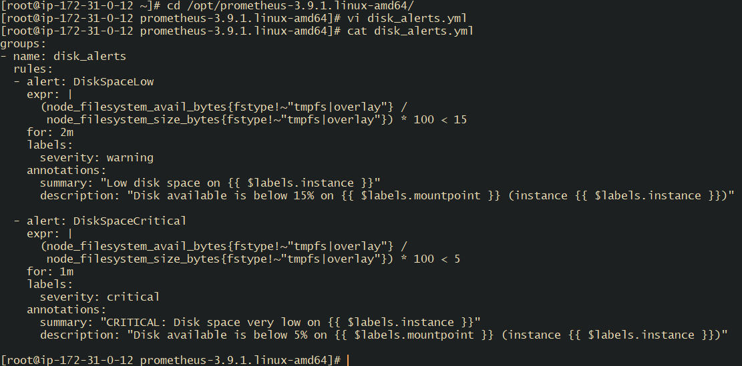
Link this file to Prometheus.yml file
#vi Prometheus .yml
- “disk_alerts.yml”
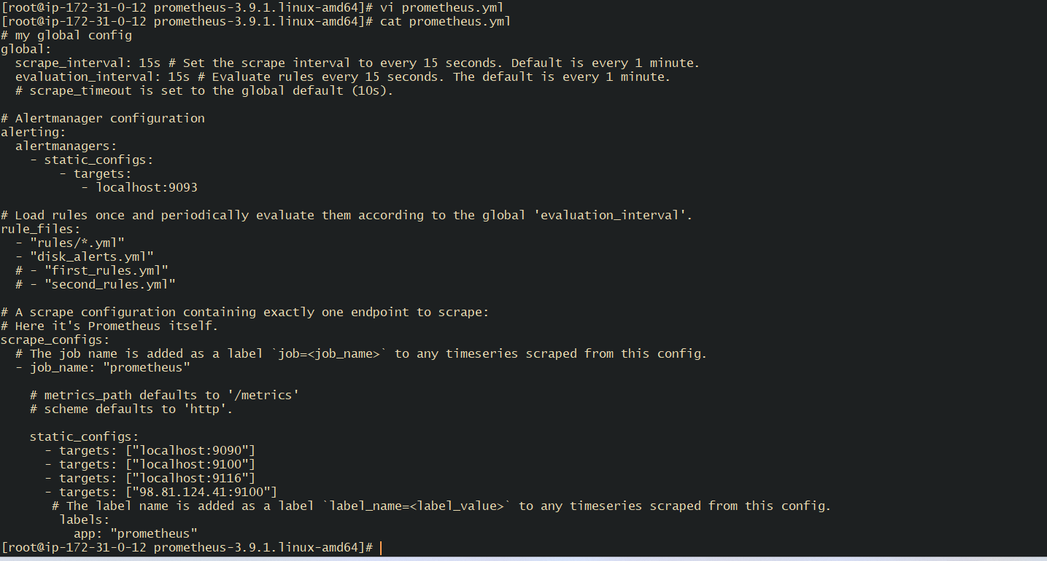
“Read this prometheus.yml file and check if it is valid.”
# /opt/prometheus-3.9.1.linux-amd64/promtool check config /opt/prometheus-3.9.1.linux-amd64/prometheus.yml
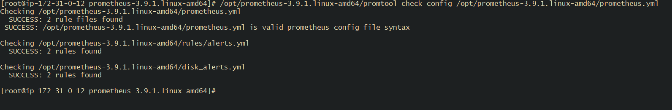
# systemctl restart Prometheus
#systemctl status prometheus
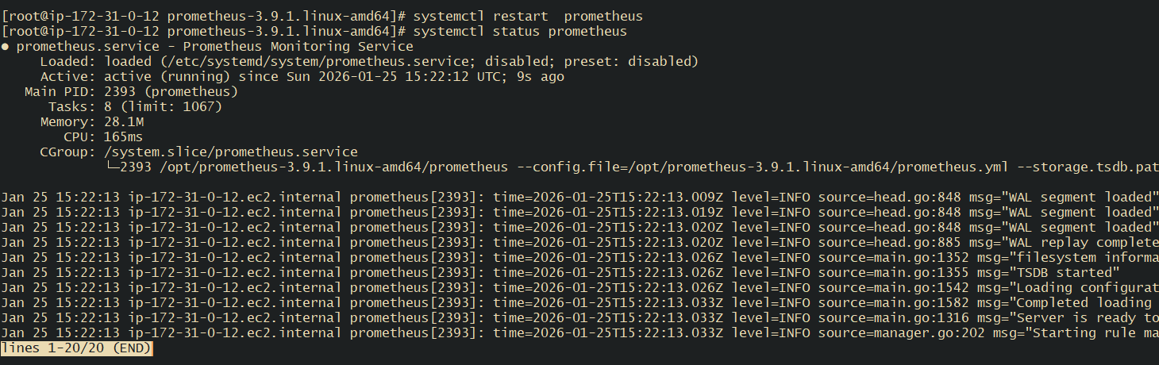
Check in the alerts in Prometheus gui
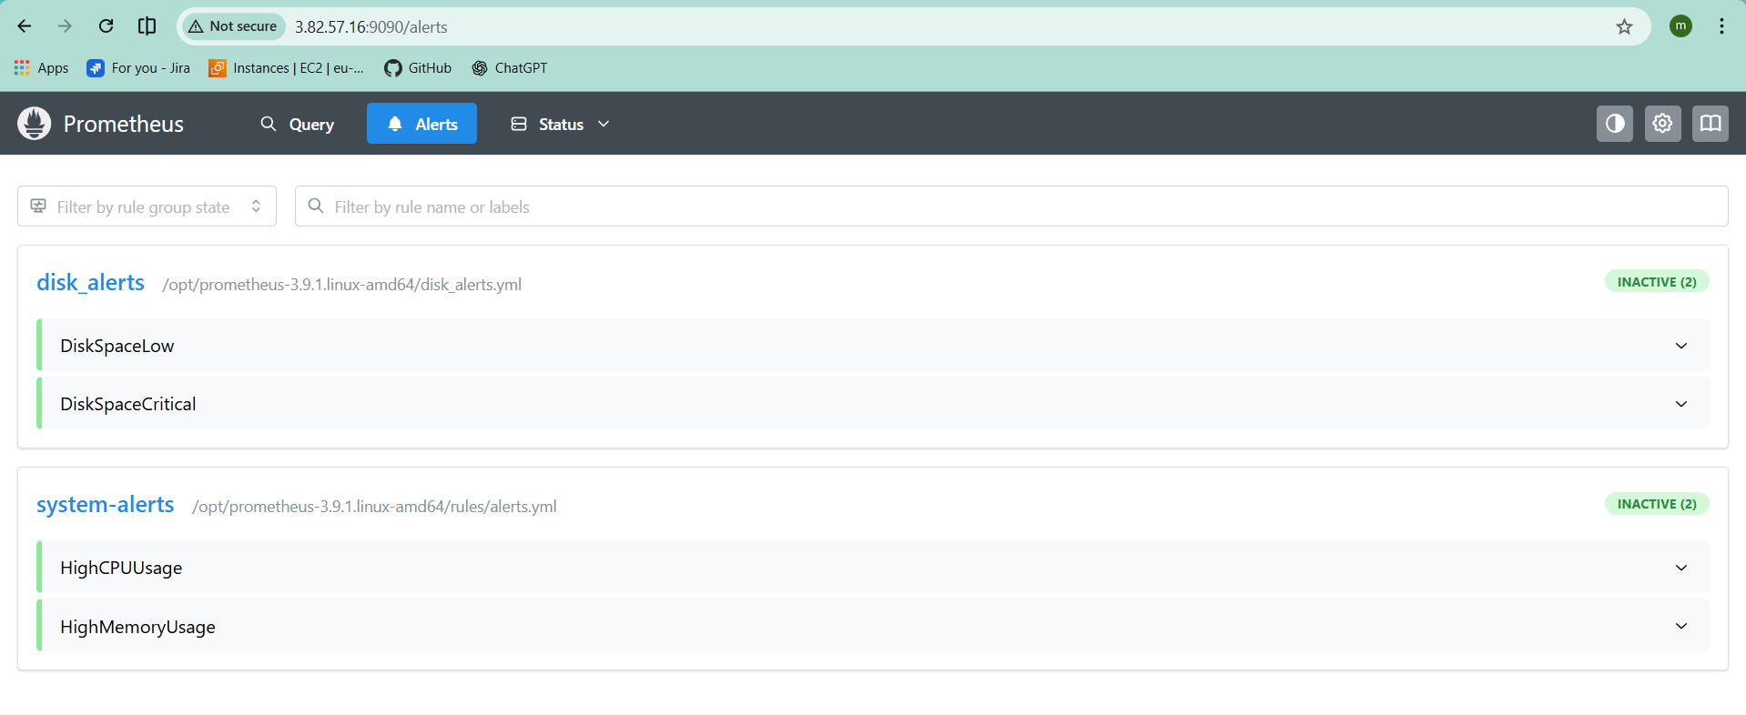

Create a custom Grafana dashboard using Prometheus metrics for specific insights.
Go to data source select Prometheus as data source Click on new dashboard and select Prometheus
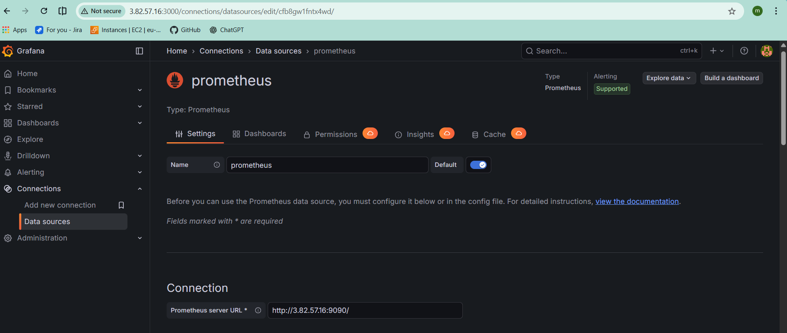
Go to dash board
Cpu:
100 - (avg by(instance) (irate(node_cpu_seconds_total{mode="idle"}[5m])) * 100)
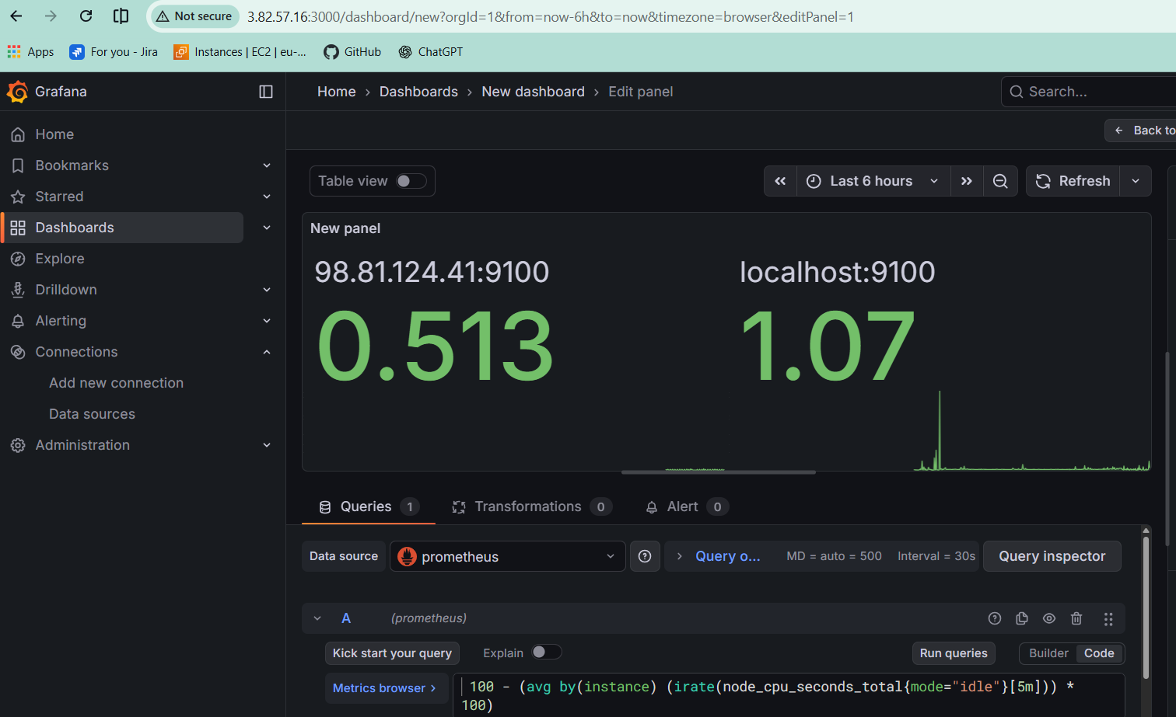
Memory:
• 100 - ((node_memory_MemAvailable_bytes / node_memory_MemTotal_bytes) * 100)
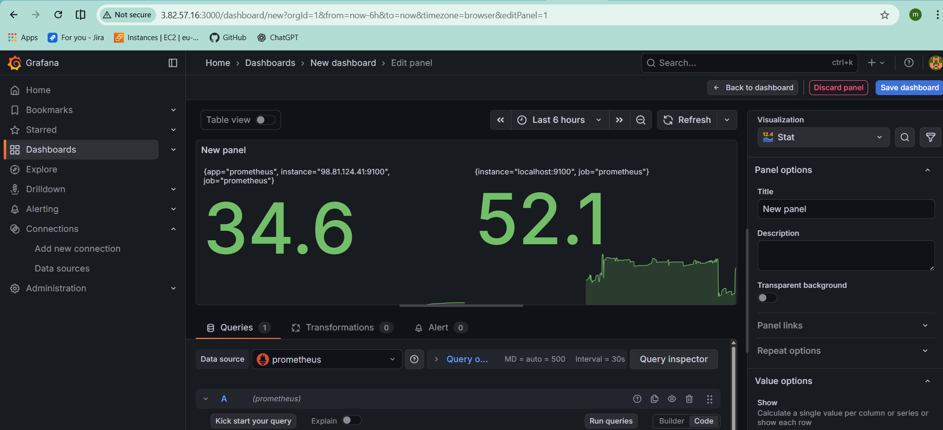
Disk usage:
• 100 - (node_filesystem_avail_bytes{mountpoint="/"} / node_filesystem_size_bytes{mountpoint="/"} * 100)
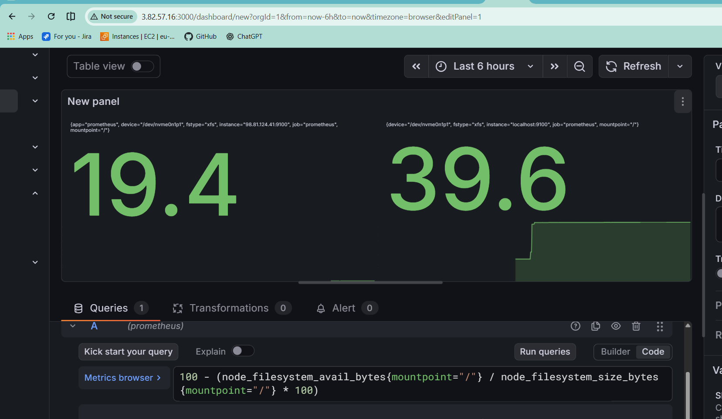
Network traffic:
• rate(node_network_receive_bytes_total[5m])
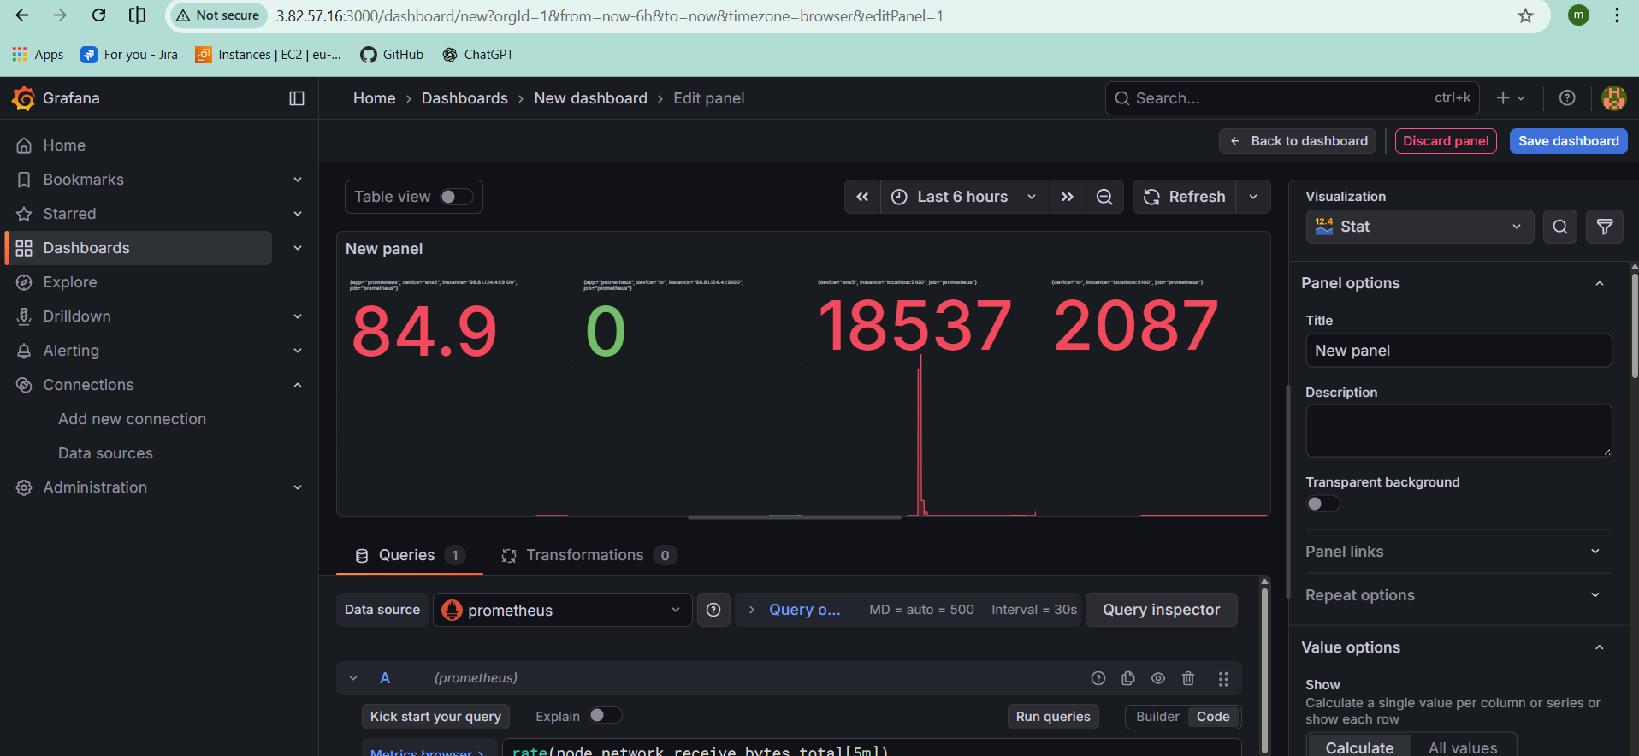
System load:
• node_load1
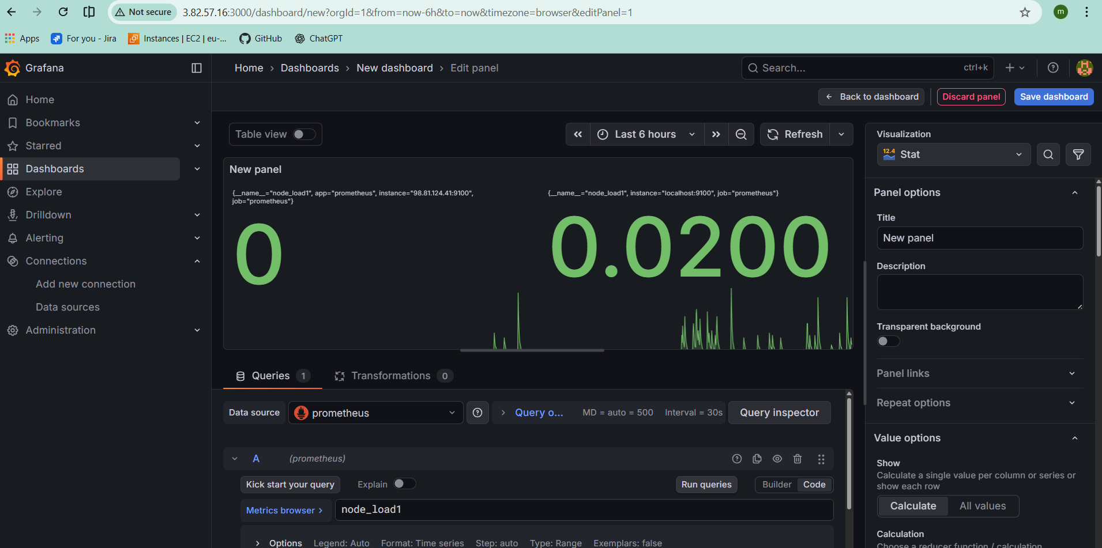
Click on dashboardsettings
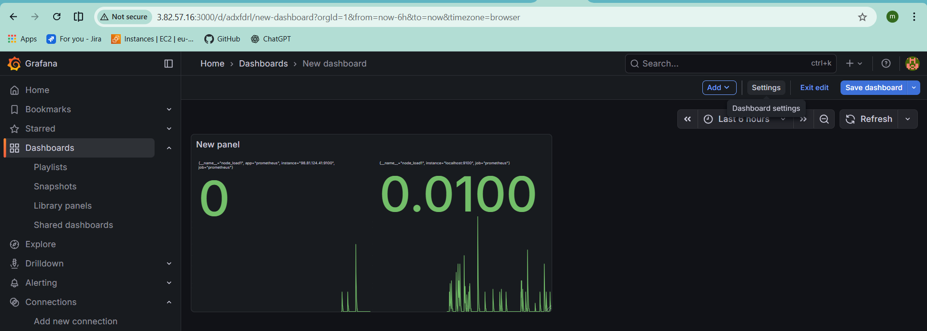
Add variable name as instance and give a query anything you want and click on save dashboard then you will see your dashboard
